
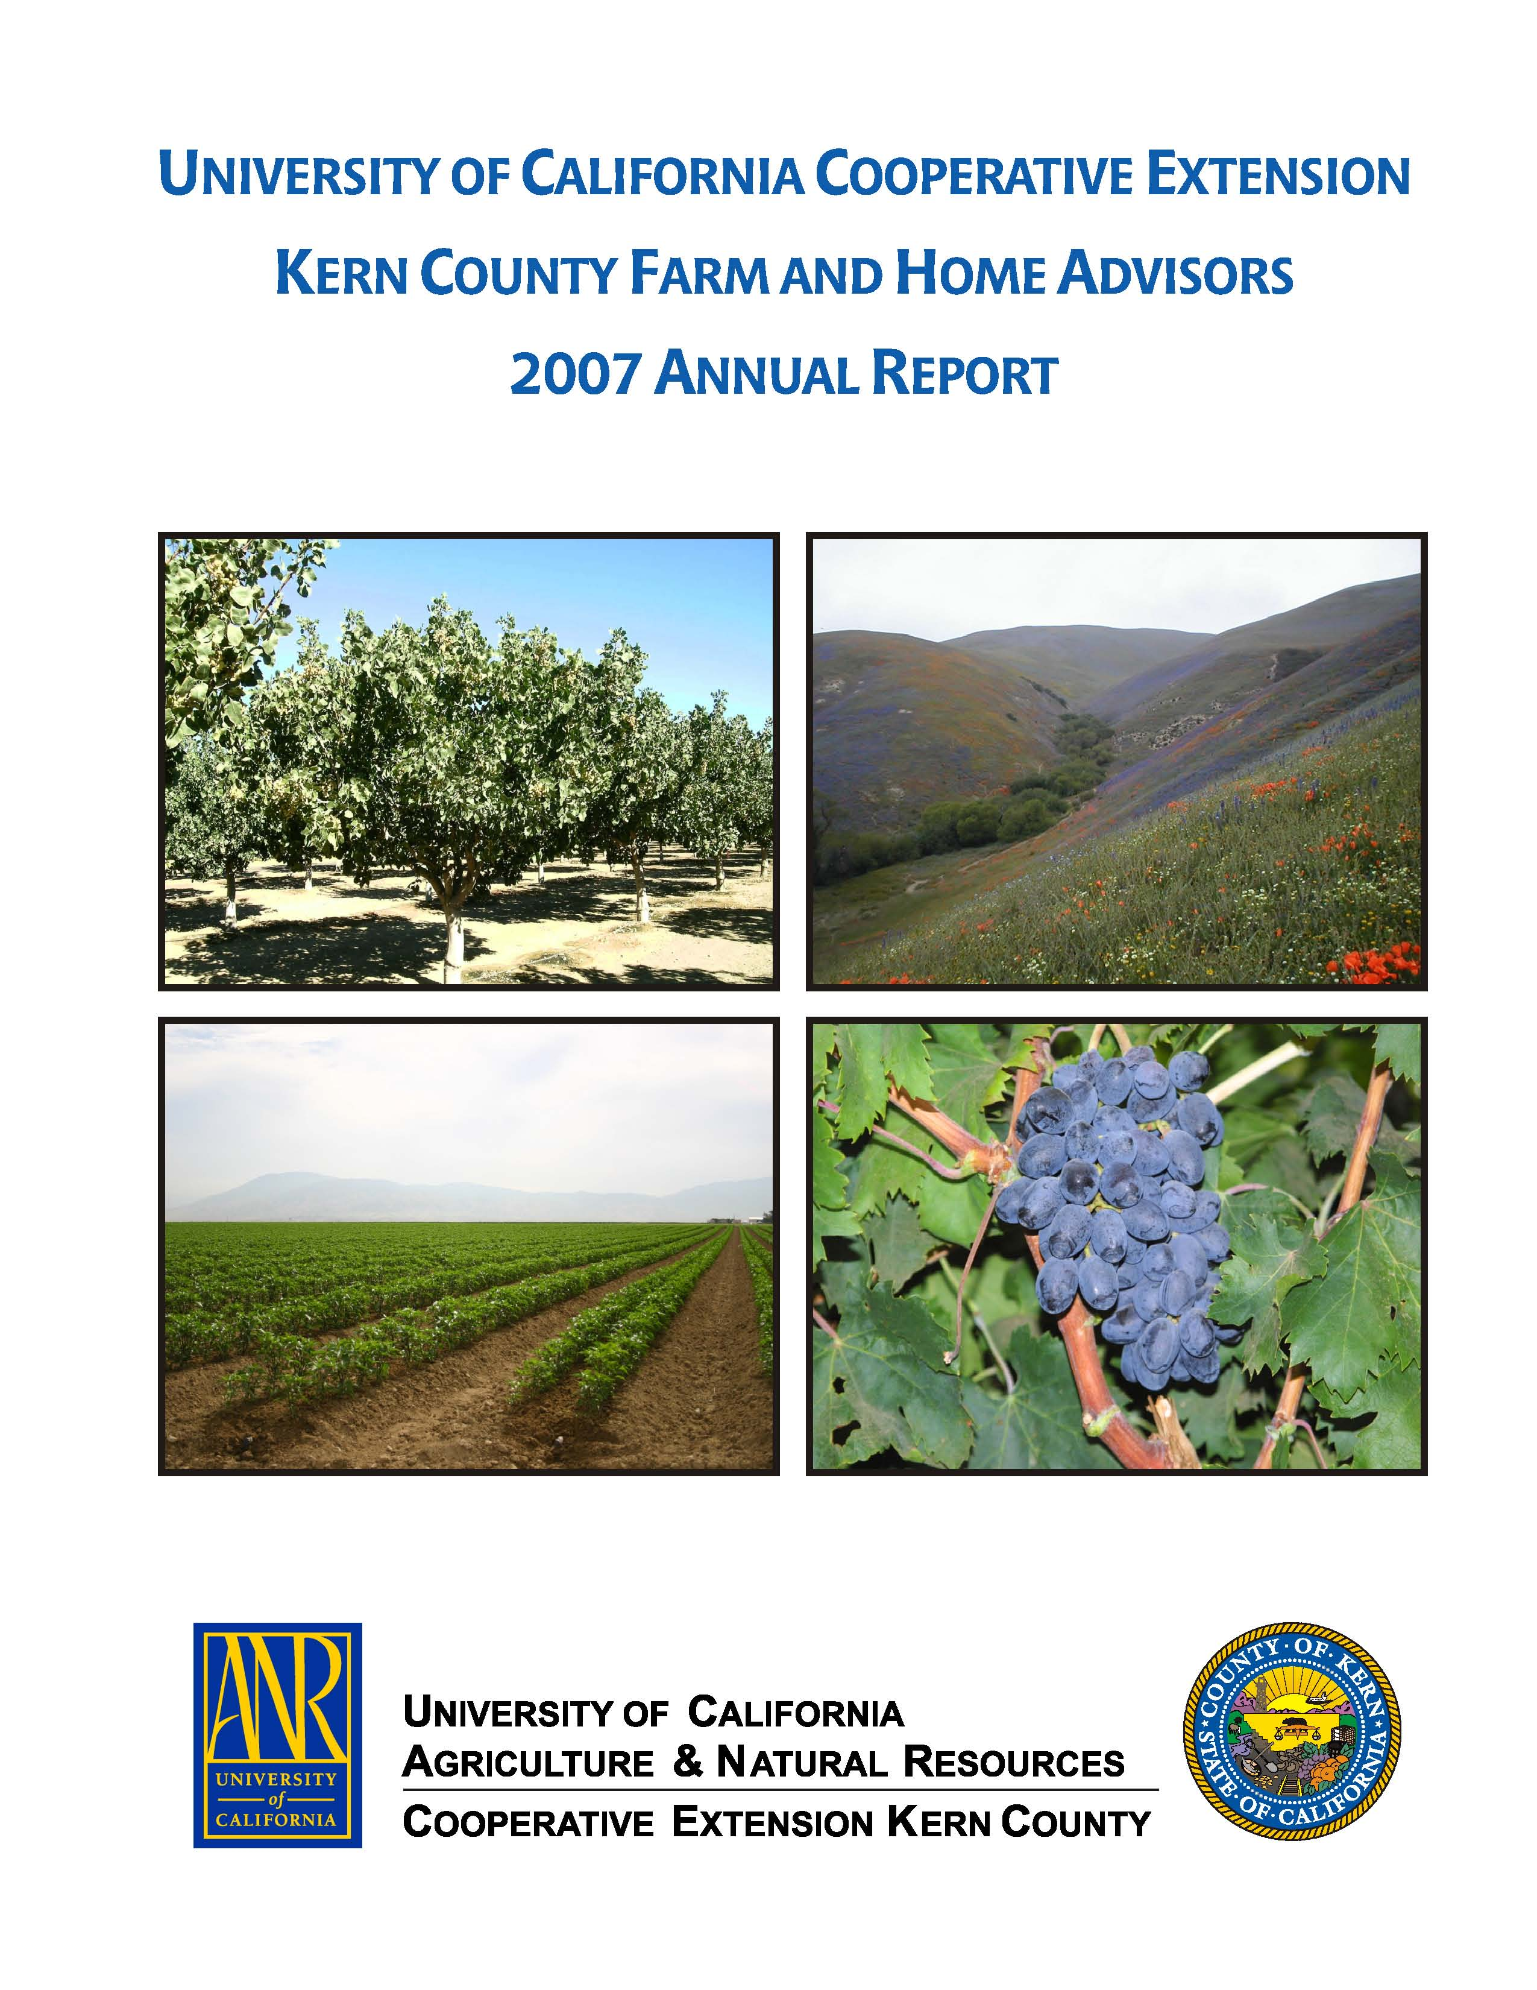
University of California Cooperative Extension – Kern County
NEWS RELEASE
1031 S. Mt. Vernon Avenue • Bakersfield, CA 93307 • 661-868-6200 • http://cekern.ucdavis.edu

May 26, 2009 Craig Kallsen, Farm Advisor

Citrus, Subtropical Horticulture, Pistachios
(661) 868-6221
Kalehghouchi Pistachio Keeping Pace with Kerman in
University of California Trials

California growers have had limited information on which to base decisions for choosing a cultivar to produce pistachio. A decade or so ago, I authored an article describing a selection from the Kalehghouchi cultivar that a California grower had brought from Iran and from which he was successfully growing pistachio. This grower was generously making budwood available from this cultivar as a gift to the pistachio industry. While this grower spoke highly of Kalehghouchi and its characteristics, little scientifically-derived data was available about its performance. To correct this deficiency, two replicated and randomized test trials comparing Kalehghouchi with Kerman, the industry standard, were established in Kern County, California. One trial was located on the east side (near Highway 65 and Garces Highway) and the other on the west side of the San Joaquin Valley (northwest of the town of Lost Hills). The trials were budded in 1998 and, after more than a decade of collecting data, it is now possible to write more authoritatively about its characteristics compared to Kerman. Kalehghouchi is at full bloom approximately seven days before Kerman. This earlier bloom requires planting a male tree with Kalehghouchi with a similar bloom period so that sufficient overlap exists for adequate pollination. The male cultivar named Randy is a suitable male pollinizer for Kalehghouchi. Compared to Kerman, Kalehghouchi tends to produce more nuts in the interior of the tree canopy. Kalehghouchi is a more vigorously growing tree than Kerman and during the growing season will produce more and longer vegetative shoots. These shoots will droop with time, and frequently will require a separate pruning late in the season so that the nut-shaking equipment will have access to the trunk at harvest in September. There have been reports that Kalehghouchi nuts become more difficult to shake with time, but in these two test plots to date, Kalehghouchi nuts have shaken from the trees as easily and cleanly as Kerman, if not more so. Nut yield has been similar between Kerman and Kalehghouchi, and Kalehghouchi, on average, has been ready for harvest at the same time as Kerman, or perhaps, a few days earlier (see Table 1). A higher percentage of the yield of Kalehghouchi have been split, edible in-shell nuts. Kalehghouchi has had on average larger, heavier nuts than Kerman. Associated with larger nut size is a tendency for a reduced shell-hinge strength, which may result in a slightly higher percentage of the nuts falling apart during processing. Nuts that fall apart during hulling are placed in the category of loose shells and kernels.
Kalehghouchi should not be thought of as a replacement for Kerman, which has a long proven track record in California. Kalehghouchi, though, appears to be a valid option for increasing cultivar diversity in the California San Joaquin Valley pistachio industry based on its performance to date in these two trials.

Table 1. Selected yield and nut quality performance characteristics compared between Kerman (the industry standard) and Kalehghouchi pistachio in two University of California scientific trials, 2003-2008. Trees were in 11th leaf in 2008.
characteristic | Lost Hills, Kern County | Highway 65, Kern County
characteristic | Kalehghouchi Kerman | Kalehghouchi Kerman
Cumulative edible yield, lbs/acre | 12949 a¹ 13226 a | 10744 a 9241 a
Cumulative clean, edible, split nuts, lbs/acre | 12369 a 12187 a | 10354 a 8763 a
Average clean, edible, split nut, % | 85.1 b 75.3 a | 87.2 b 77.6 a
Average closed shell, all sources, % | 8.1 a 18.8 b | 7.5 a 18.7 b
Average loose shells and kernels, % | 1.4 b 0.5 a | 1.5 b 0.6 a
Average insect damage, % | 1.3 a 1.1 a | 0.3 a 0.4 a
Average individual nut weight, grams | 1.43 b 1.23 a | 1.43 b 1.36 a
Average harvest readiness date compared to Kerman, in days | -2 0 | 0 0
¹ Values in the same cell followed by different letters are significantly different by Fisher’s protected LSD test a P ≤ 0.05.

