
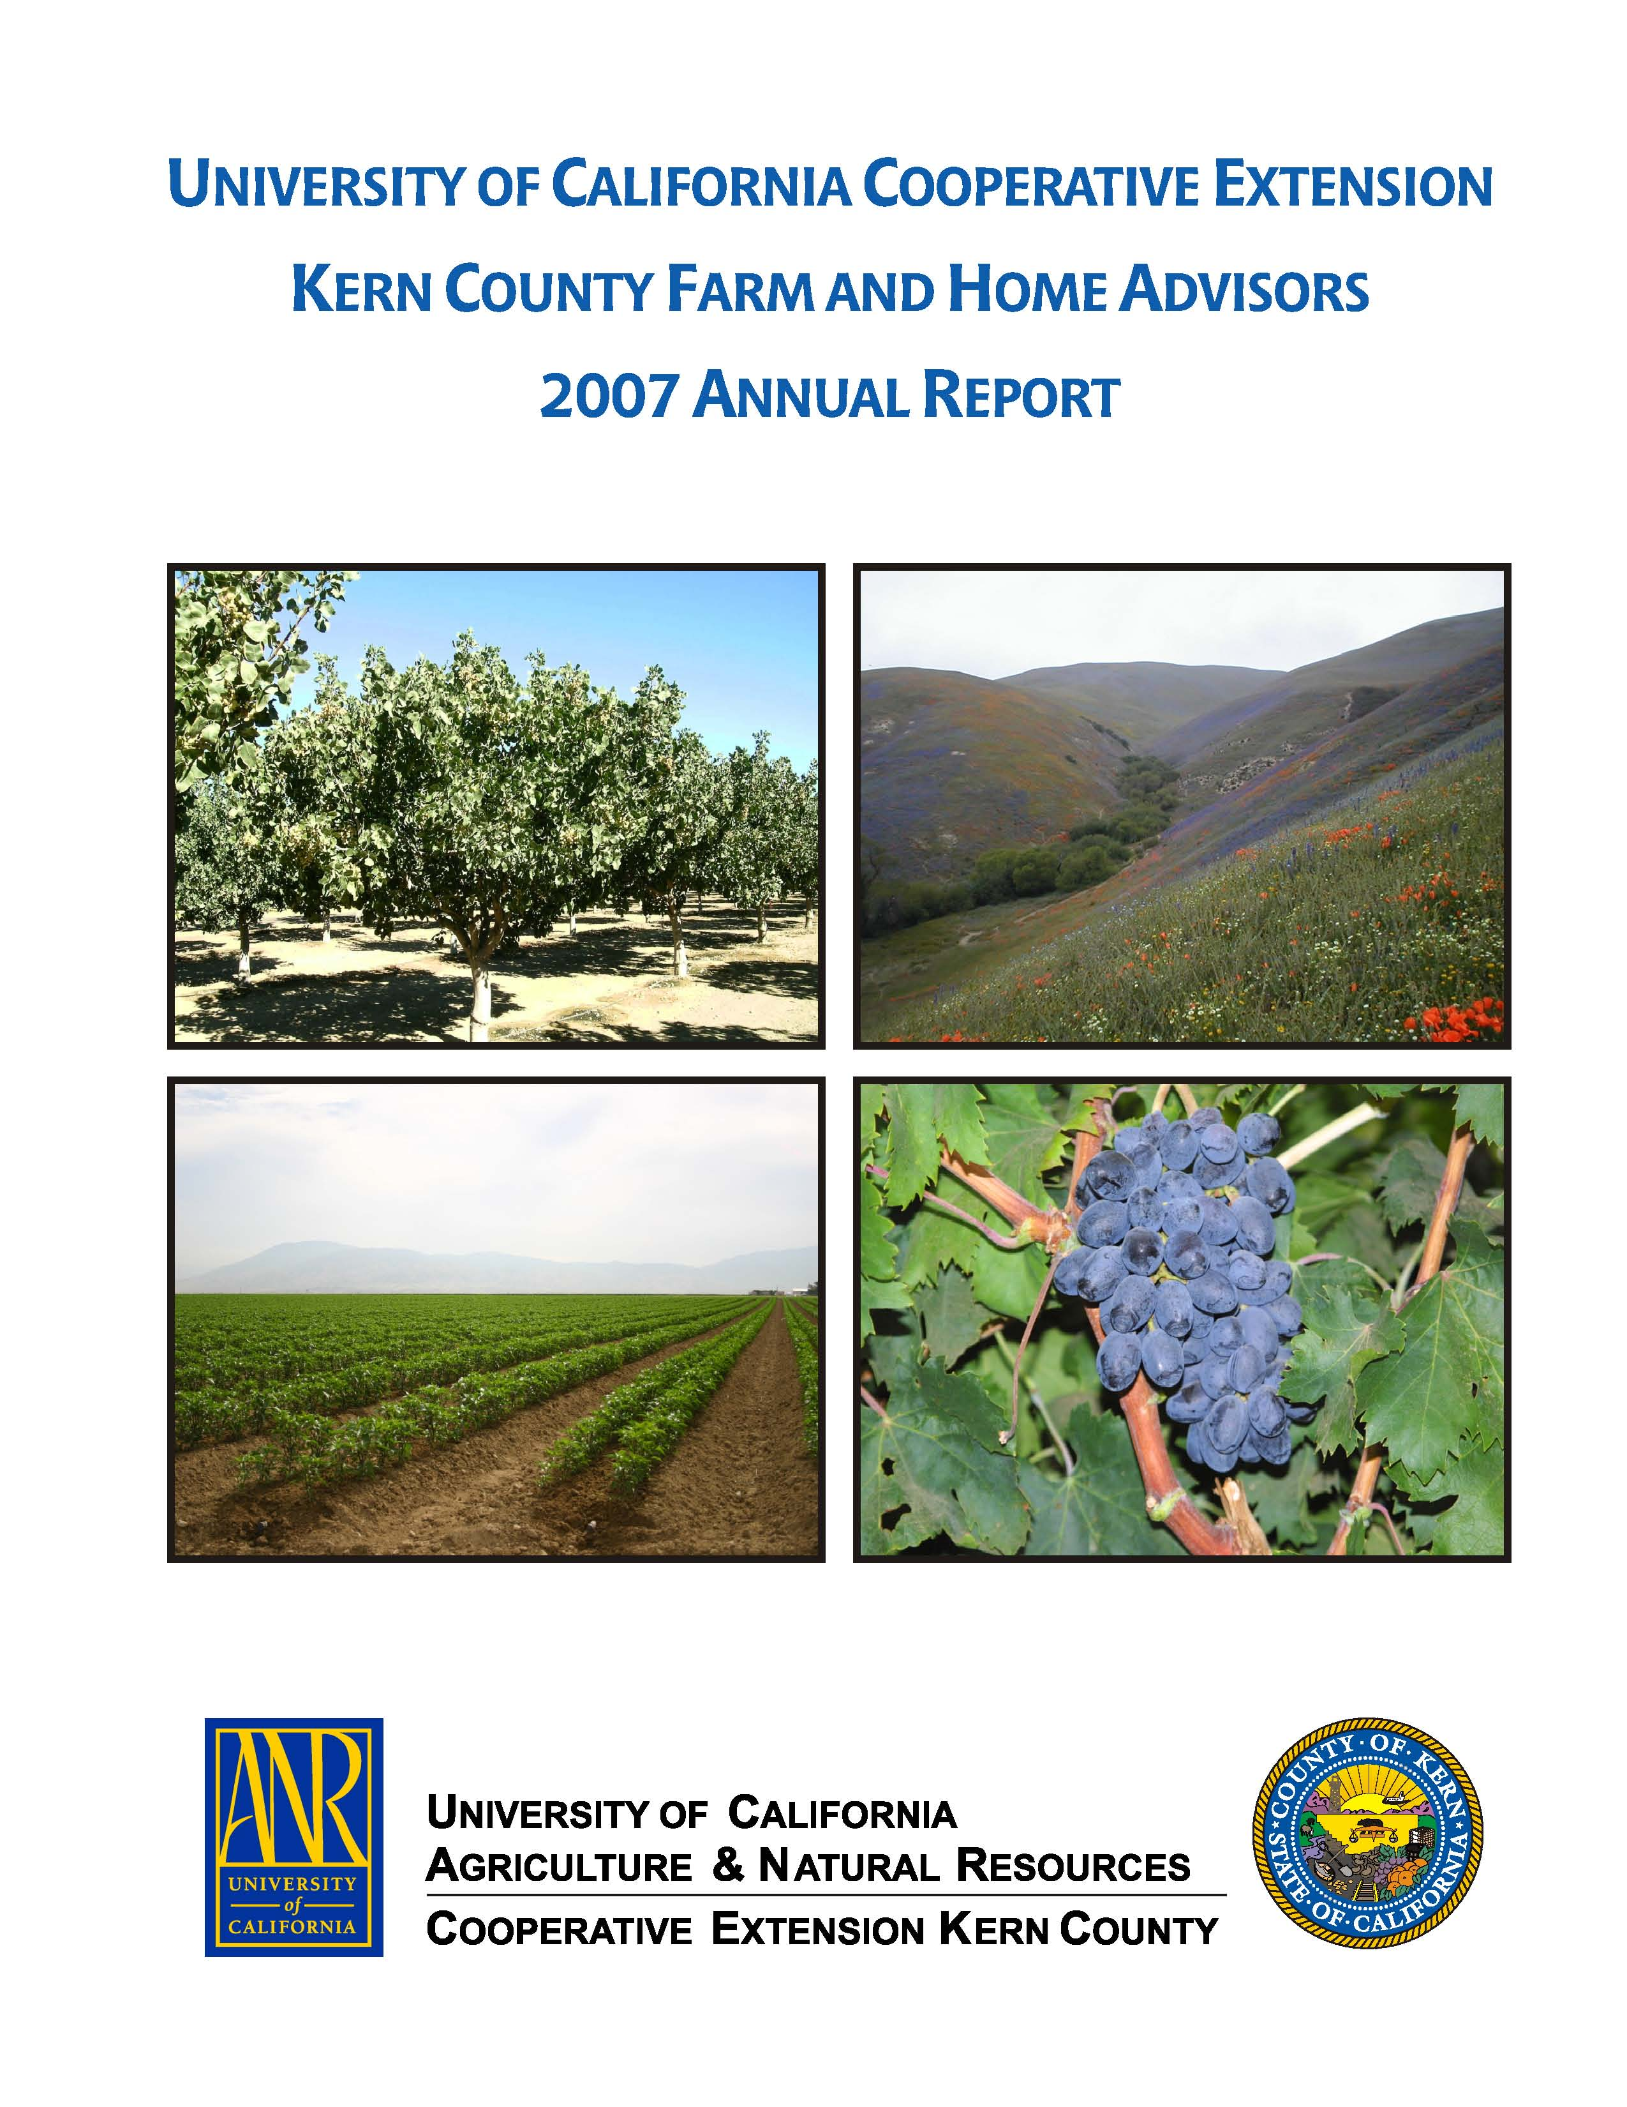
University of California Cooperative Extension – Kern County
NEWS RELEASE
1031 S. Mt. Vernon Avenue • Bakersfield, CA 93307 • 661-868-6200 • http://cekern.ucdavis.edu

July 28, 2009 Craig Kallsen, Farm Advisor

Citrus, Subtropical Horticulture, Pistachios
(661) 868-6221
Improve Control and Reduce Costs by Trapping California Red Scale

The citrus industry is justifiable concerned by the unintended introduction of exotic pests, such as the Asian Citrus Pysillid, to California. However, while keeping an eye on the new exotics, grower profitability necessitates that attention remain on many of the serious pests that have been with us for decades or more. California red scale (CRS), a pest that industry made a valiant attempt to eradicate decades ago, is one such pest. Every citrus grower should have a strategy to control CRS. California red scale infestations can seriously impact fruit quality and yield, especially in California’s San Joaquin Valley, where biocontrol is more problematic. Biological control tends to be easiest in the coastal areas and some inland districts of southern California because milder weather in these regions allows the overlap of generations, which provides susceptible host stages for parasitism year round. However, even in the San Joaquin Valley, many growers achieve control without annual pesticide applications. Some growers achieve satisfactory control by releasing supplementary parasitic wasps and by encouraging biological control of most citrus pests through the minimal use of pesticides.
Many other growers reduce the number of pesticide applications made to CRS through careful monitoring of this pest by visual evaluation of foliage and fruit in combination with the use of pheromone traps. The most commonly used trap design is a white card, covered with a sticky substance, to which a cap containing a female-sex pheromone is attached with a paper clip. Male scale fly, females do not. Males fly to find females to fertilize. The pheromone attracts flying male red scale to the trap where they are captured. In the San Joaquin Valley, CRS is able to complete four generations, so; generally, four peak populations of male scale (called flights) are trapped annually. The first flight occurs in April-May, the second in June-July, and the third and fourth flights are more difficult to separate. The fourth flight normally occurs in September-October. Left uncontrolled, CRS populations increase greatly in numbers in later generations and these generations begin overlapping by the third flight. The traps provide information on both the overall population density, and when reproductive events are taking place. For best results, the traps are used in combination with calculation of degree days based on temperature models to determine the most effective time for pesticide applications. Pesticides are usually targeted at the first or second generation, but timing the application within the generation varies with the mode of action of a given pesticide. Some materials are aimed prior to or during the peak egg hatch or later as the nymphs molt between developmental stages. Visual examination of the twigs earlier in the season or the fruit after early July can assist in confirming scale density within areas of the orchard and scale developmental stages.
Often population densities in the first and second flights are so low that, even in orchards at risk, that information from the fourth or last flight of the previous year should be used to evaluate the need for pesticide treatment in the following year. However, first and second flight trapping is critical for determining generational appearance and development in the spring and summer. Nymphs from the first and second generation are the usual targets for control, since numbers are lower and population peaks are more distinct. If overall population numbers remain beneath accepted economic thresholds, pesticide sprays are unnecessary. Sometimes only portions of large blocks of citrus will need to be treated based on variable population densities in the same orchard.
More complete information on the use of trapping to control California red scale is available at http://www.ipm.ucdavis.edu/PMG/r107301111.html or in the following manual: Integrated Pest Management for Citrus, 2nd Edition, University of California, Statewide Integrated Pest Management Project, ANR Publication 3303. 1991.
A workshop, sponsored by the University of California, called “California Red Scale Monitoring and Management” will be held Wednesday, August 26, 2009 from 8:30 – 10:30 a.m. at the Shafter Research and Extension Center at 17053 Shafter Avenue, Shafter CA 93263. 

