
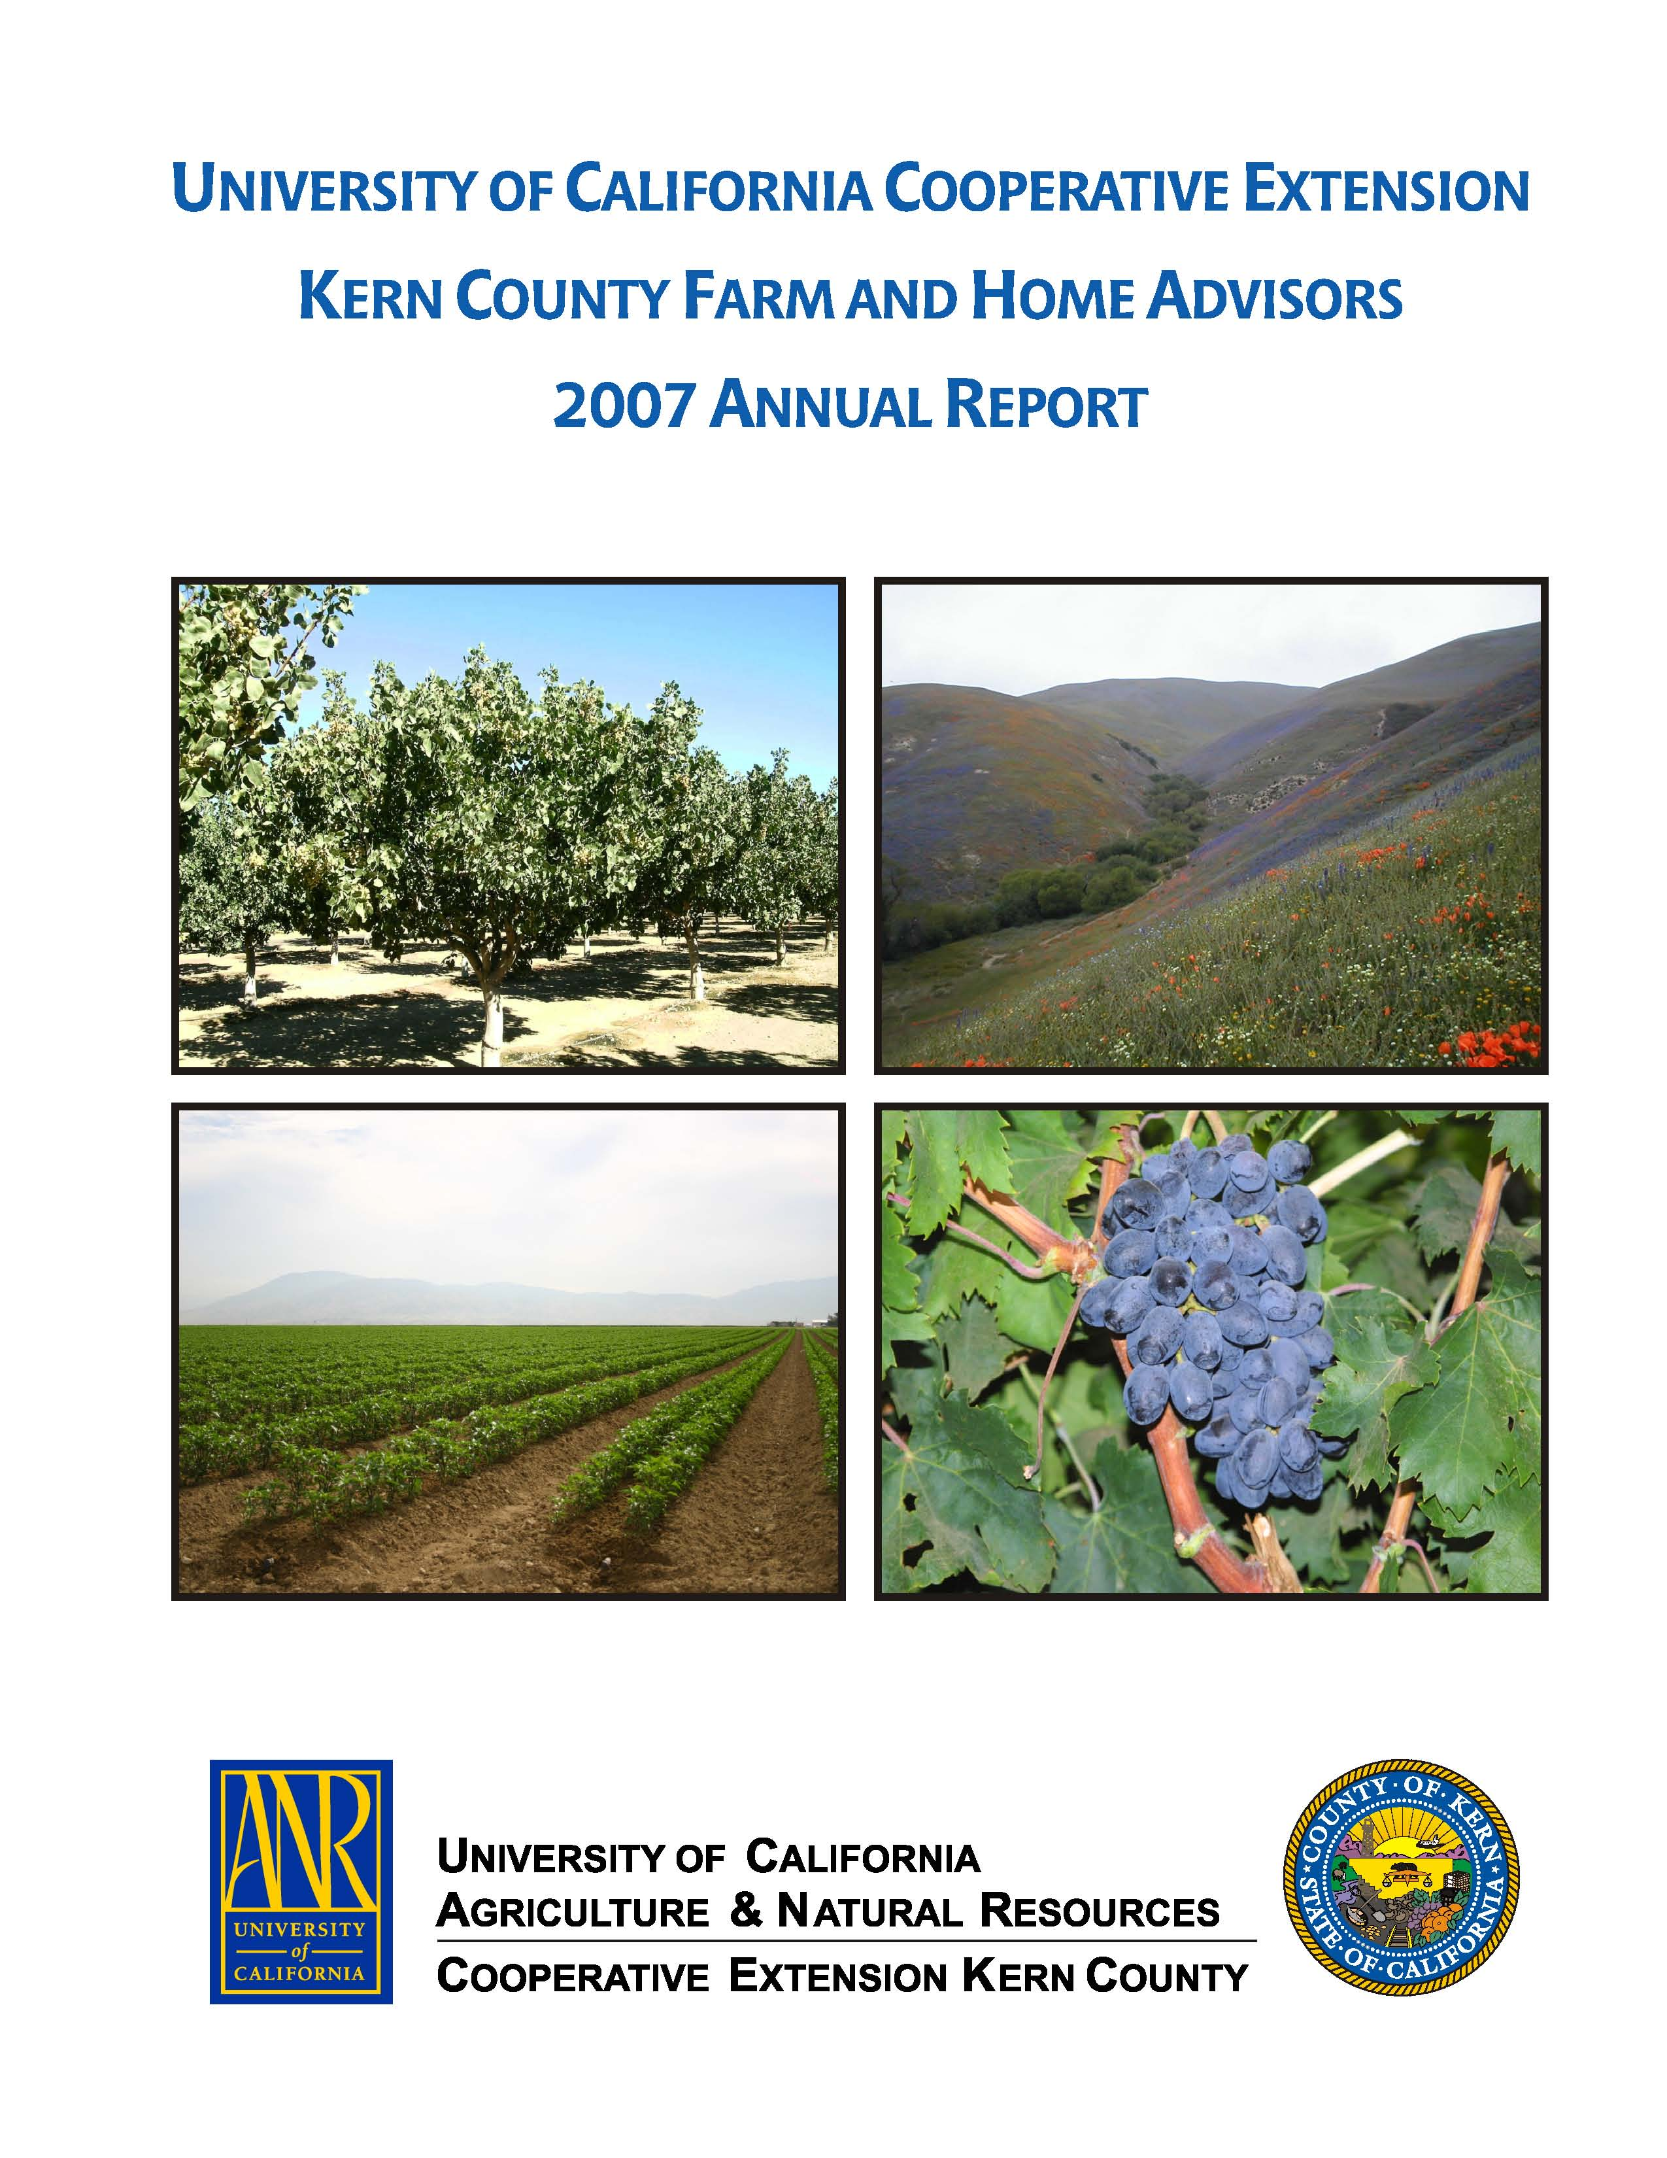
University of California Cooperative Extension – Kern County
NEWS RELEASE
1031 S. Mt. Vernon Avenue • Bakersfield, CA 93307 • 661-868-6200 • http://cekern.ucdavis.edu

December 9, 2009 Craig Kallsen, Farm Advisor

Citrus, Subtropical Horticulture, Pistachios
(661) 868-6221
2010 ANNUAL STATEWIDE PISTACHIO DAY
On the Way

The annual Statewide Pistachio Day, sponsored by the University of California Cooperative Extension, is the premier pistachio gathering in the Central Valley and should not be missed by anyone wanting to remain current with the latest research and industry developments. Fungal pathogens of pistachio are always a concern, especially in 2009 when Botryosphearia disease made its deepest assault into Kern County ever. Dr. Themis Michailides, plant pathologist at the U.C. Kearney Agricultural Center, will be discussing management guidelines for this disease, as well as for Alternaria blight. Additional presentation topics to be covered include: understanding salinity, navel orangeworm control, new cultivar update and the effect of Surround® on water relations and yield. Dr. Bob Klein of the Pistachio Research Board will conclude with information on food safety challenges facing the pistachio industry. Registration begins at 7 am, Wednesday, January 13, 2010 at the Visalia Convention Center (303 E. Acequia Ave., Visalia California. 93291) and adjourns at 12:30 pm. Pre-register online at http://fruitsand nuts.ucdavis.edu (under “What’s New”) and avoid the extra cost and frustration of registering on meeting day. 

