
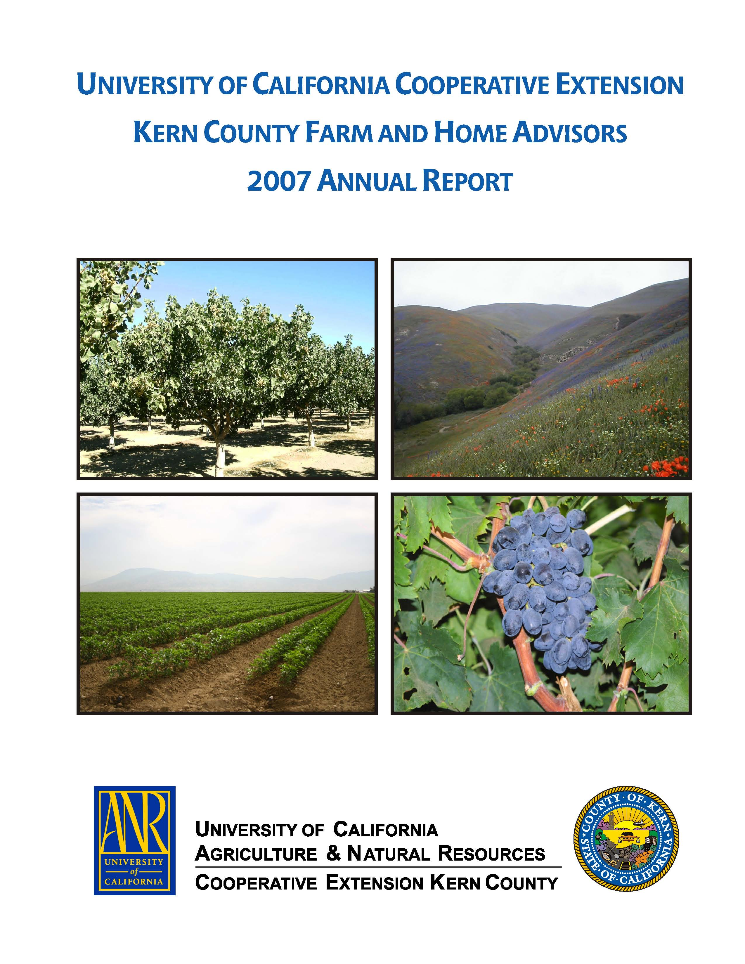
University of California Cooperative Extension
PISTACHIO NOTES
Kern County • 1031 S. Mt. Vernon Avenue • Bakersfield, CA 93307 • 661-868-6221

2009 ANNUAL STATEWIDE PISTACHIO “Water” DAY

Visalia Convention Center, 303 East Acequia - Visalia, California
Wednesday, January 14, 2009, 7:00 am - 1:30 pm
Registration begins at 7:00 am

Registration for Pistachio Day 2009 is required since a hot lunch will be included. Registration fee is $30. If you have questions, please call Penny Stockdale 530-754-8523 or Louise Ferguson at 530-752-0507.

Agenda

7:00 a.m. PCA and continuing education credits sign-up

“Water Boys” Moderators
Dr. Brent Holtz and Robert Beede,
UCCE Farm Advisors, Madera and Kings Counties

8:00 a.m. California Water: Managing Crisis and Opportunity
Tim Quinn, Director, Association of California Water Agencies (ACWA)
8:30 a.m. Water Relations, Water Requirements, and Irrigation Scheduling
Dr. David Goldhamer, Irrigation Specialist, UC Davis
9:15 a.m. Drought Strategies: How to Best Manage a Limited Water Supply and Impact on Current and Future Production
Dr. David Goldhamer, Irrigation Specialist, UC Davis
10:00 a.m. Fine Tuning your Micro-Irrigation System
Dr. Larry Schwankl, Irrigation Specialist, UC Davis
10:30 a.m. Break

Moderator, Craig Kallsen, Farm Advisor, UCCE Kern County

11:00 a.m. Water and Botryosphaeria and Alternaria Blights
Dr. Themis Michailides, Plant Pathologist, UC KAC/UC Davis
11:30 a.m. Navel Orangeworm sanitation, insecticide efficacy, and factors related to damage
Dr. Joel Siegel, USDA-ARS, Entomologist, Parlier
12:00 p.m. Navel Orangeworm management: results from large scale field trials
Dr. Brad Higbee, Research Entomologist, Paramount Farming Company
12:30 p.m. Lunch
Update of Western Pistachio Association and California Pistachio Research
Board Activities
Dr. Bob Klein or Tom Coleman

Registration Form and Information Located at End of This Newsletter

December 2008

Evaluation of Pistachio Cultivars Golden Hills and Lost Hills Continues

C.E. Kallsen, Dr. Dan Parfitt, and Brent Holtz

In 1990, the then California Pistachio Commission supported the creation of a new UCD Pistachio Breeding Program conducted by Mr. J. Maranto, then UCCE farm advisor in Kern County, and Dr. D. Parfitt. The objective of the research would be to produce and identify cultivars with nut quality characteristics superior to Kerman, such as increased size, less blanking and less closed shell, or with other valuable characteristics such as varying nut-maturity dates. Adding new cultivars might also buffer the genetic vulnerability that monoculture creates when a new pest or disease attacks a particular cultivar.
The breeding program created a large germplasm from crosses of available male and female cultivars. Nine female seedlings that appeared to have useful yield, nut quality and maturation times were selected for propagation on rootstocks in scientific trials. Advanced selection trials were established in 1997, in northwestern Kern County; and in 1999, near Madera in Madera County. In 2005, two of these selections, Golden Hills and Lost Hills were released by the University of California as cultivars, along with an early-flowering male cultivar called ‘Randy’ suitable as a pollinator for the female cultivars. Performance of these cultivars compared to Kerman appear in Tables 1 and 2 (northwestern Kern County) and Tables 3 and 4 (Madera County). At both trial locations, the nut of the Lost Hills cultivar continued to demonstrate a propensity toward weaker shell-hinge strength. In Kern County in 2008, Golden Hills demonstrated a wider range of nut size than did Kerman or Lost Hills. An unusually high percentage of Golden Hills nuts fell through the 30/64 inch screen, yet this cultivar had a similar average nut weight to the other two cultivars signifying that a high percentage of larger nuts must also have been present. In Kern County in 2008, both Kerman and Golden Hills showed reduced yields as a result of strong on-year production in 2007, while Lost Hills further demonstrated reduced alternate bearing compared to Kerman and Golden Hills. Alternate bearing is not yet apparent in Madera in any cultivar. The later harvest of all of the cultivars than normal, probably contributed to similar and higher levels of insect damage at both locations. Lost Hills and Golden Hills continued to be ready for harvest about two weeks before Kerman.

Table 1. Yield for 2008 and cumulative edible yield of Kerman, Golden Hills and Lost Hills in northwestern Kern County. Cumulative yield is for 6th through 12th leaf.
cultivar | total yield, 2008, lbs/acre | edible yield, 2008, lbs/acre | cumulative edible yield, 2002 – 2008, lbs/acre | total insect damage, all sources, % | harvest readiness date, 2008
Kerman | 544 a ^{z} | 523 a | 16795 a | 1.7 a | Sept. 12
Golden Hills | 1414 a | 1311 a | 23238 b | 1.6 a | Aug. 27
Lost Hills | 4754 b | 4635 b | 21212 b | 2.4 a | Aug 29
^{z} Different letters in the same column denote significant differences using Fisher’s protected LSD test at P ≤ 0.05

Table 2. Individual nut weight and selected nut quality characteristics for 2008 of 12th leaf Kerman, Golden Hills and Lost Hills cultivars in northwestern Kern County.
cultivar |  | edible split inshell, % | shelling stock, all sources, % |  | closed shell, all sources, % |  | loose kernels and shells ^{z}, % |  | nuts smaller than 30/64 inch ^{z}, % |  | individual nut weight, grams
Kerman |  | 81.1 a ^{y} | 7.3 a |  | 8.7 a |  | 0.6 a |  | 0.0 a |  | 1.21 a
Golden Hills |  | 80.8 a | 12.0 a |  | 3.3 a |  | 0.8 a |  | 8.7 b |  | 1.26 a
Lost Hills |  | 86.0 a | 5.8 a |  | 5.3 a |  | 2.5 b |  | 2.7 a |  | 1.32 a
^{z} This nut quality factors is a component of shelling stock.
^{y} Different letters in the same column denote significant differences using Fisher’s protected LSD test at P ≤ 0.05
Table 3. Yield for 2008 and cumulative edible yield of Kerman, Golden Hills and Lost Hills cultivars in Madera County. Cumulative yield is for 6th through 10th leaf.
cultivar | total yield, 2008, lbs/acre |  |  | edible yield, 2008, lbs/acre |  | cumulative edible yield 2002 – 2008, lbs/acre |  | Total insect damage, all sources, % |  | Harvest readiness date, 2008
Kerman | 3704 a ^{z y} |  |  | 3623 a |  | 9067 a |  | 1.2 a |  | Sept. 16
Golden Hills | 4379 a |  |  | 4252 a |  | 10587 a |  | 2.0 a |  | Aug. 31
Lost Hills | 4667 a |  |  | 4548 a |  | 10848 a |  | 2.1 a |  | Sept. 2
^{z} Different letters in the same column denote significant differences using Fisher’s protected LSD test at P ≤ 0.05
^{y} Values for Madera are the average of cultivar performance on PG1 and UCB-1 rootstock. Effects of rootstock on yield and harvest date across cultivars were not significant.

Table 4. Individual nut weight and selected nut quality characteristics for 2008 of 10th leaf Kerman, Golden Hills and Lost Hills in Madera County.
cultivar | edible split inshell, % | shelling stock, all sources, % | closed shell, all sources, % | loose kernels and shells ^{z}, % | nuts smaller than 30/64 inch ^{z}, % | individual nut weight, grams
Kerman | 87.6 a ^{yx} | 3.1 a | 8.6 b | 1.2 a | 0.4 a | 1.52 a
Golden Hills | 88.1 a | 3.8 a | 7.3 b | 0.4 a | 0.6 a | 1.41 a
Lost Hills | 89.5 a | 5.0 a | 4.0 a | 3.1 b | 0.4 a | 1.48 a
^{z} This nut quality factors is a component of shelling stock.
^{y} Different letters in the same column denote significant differences using Fisher’s protected LSD test at P ≤ 0.05
^{x} Values for Madera are the average of cultivar performance on PG1 and UCB-1 rootstock. Effects of rootstock on yield and harvest date across cultivars were not significant.

UNIVERSITY OF CALIFORNIA COOPERATIVE EXTENSION
Open Position Advertisement

Horticulture Advisor – Orchard Crops and Systems serving Tulare County and headquartered in Tulare, CA - #ACV 08-01

The UNIVERSITY OF CALIFORNIA, DIVISION OF AGRICULTURE AND NATURAL RESOURCES, COOPERATIVE EXTENSION is seeking an academic candidate to plan, conduct and coordinate a county-based extension program of education and applied research in orchard crops and systems. The position will specialize in walnuts, almonds, pistachios, pecans, olives, and prunes. This position will address important resource, economic, environmental, and production issues of these major orchard crops. Through analysis and evaluation of local industry needs and production problems, the incumbent will develop and implement a research and education program related to orchard systems, integrating economic viability, production efficiency and preservation of the resource base, and environmental stewardship. Specific problems to be addressed may include: exotic pest control and management, irrigation and nutrition management, plant growth and crop development, integrated pest management, economic and sustainable management practices, maintaining competitiveness, evaluation and development of alternative cropping and farming systems, and precision agriculture for orchard systems.

Academic appointees in Cooperative Extension are responsible for performance in: extending knowledge and information; applied research and creative activity; professional competence and activity; and University and public service.

A minimum of a Master’s degree in horticulture or plant/crop sciences or a related discipline is required. Knowledge of applicable orchard production systems and production/management issues is highly desirable including a working knowledge of applied horticulture. Acquisition of a California Qualified Applicators Certificate (QAC) within nine months from employment is required.

Beginning salary will be in the UC Cooperative Extension Assistant Advisor rank, commensurate with applicable experience and education. The full position vacancy announcement and required academic application are available at http://ucanr.org/cvr.joblisting or email recruit08-01@uckac.edu. Complete packets must be received by February 20, 2009. Refer to position #ACV 08-01. AA/EOE
2009 Annual Statewide Pistachio Day
Registration Form

REGISTRATION (Fee: $30/person. Hot lunch included.)

Lunch?
Name (Please print or type) Yes No

❒ ❒

❒ ❒

❒ ❒

❒ ❒

❒ ❒

❒ ❒

❒ ❒

❒ ❒

Total registration fee(s): $

Registrations must be received by
Wednesday, January 7, 2009.
CONTACT INFORMATION

Registrations will be confirmed with the contact person listed below: (*required)

*Name

*Company

Address

City

State Zip Code

Phone

*E-mail

Mail form with check (made out to: UC Regents: Fruits and Nuts Research and Information Center: Pistachio Day 2008 Account) to:

Fruits and Nuts Research and Information Center
Department of Plant Sciences
Mail Stop 2
University of California
One Shields Avenue
Davis, CA 95616-8780

OR

register online with a credit card at:

http://ucanr.org/2009pistachioday

For more information, contact
University of California Fruit and Nut
Research and Information Center:
Phone: (530) 754-9708
E-mail: fruitsandnuts@ucdavis.edu

PCA & CCA credit has been requested.

The University of California, in accordance with applicable Federal and State law and University policy, does not discriminate on the basis of race, color, national origin, religion, sex, disability, age, medical condition (cancer-related), ancestry, marital status, citizenship, sexual orientation, or status as a Vietnam-era veteran or special disabled veteran. Inquiries regarding the University’s nondiscrimination policies may be directed to the Affirmative Action Director, University of California, Division of Agriculture & Natural Resources, 1111 Franklin Street, 6th Floor, Oakland, CA 94607-5200, (telephone: 510-987-0096).

