
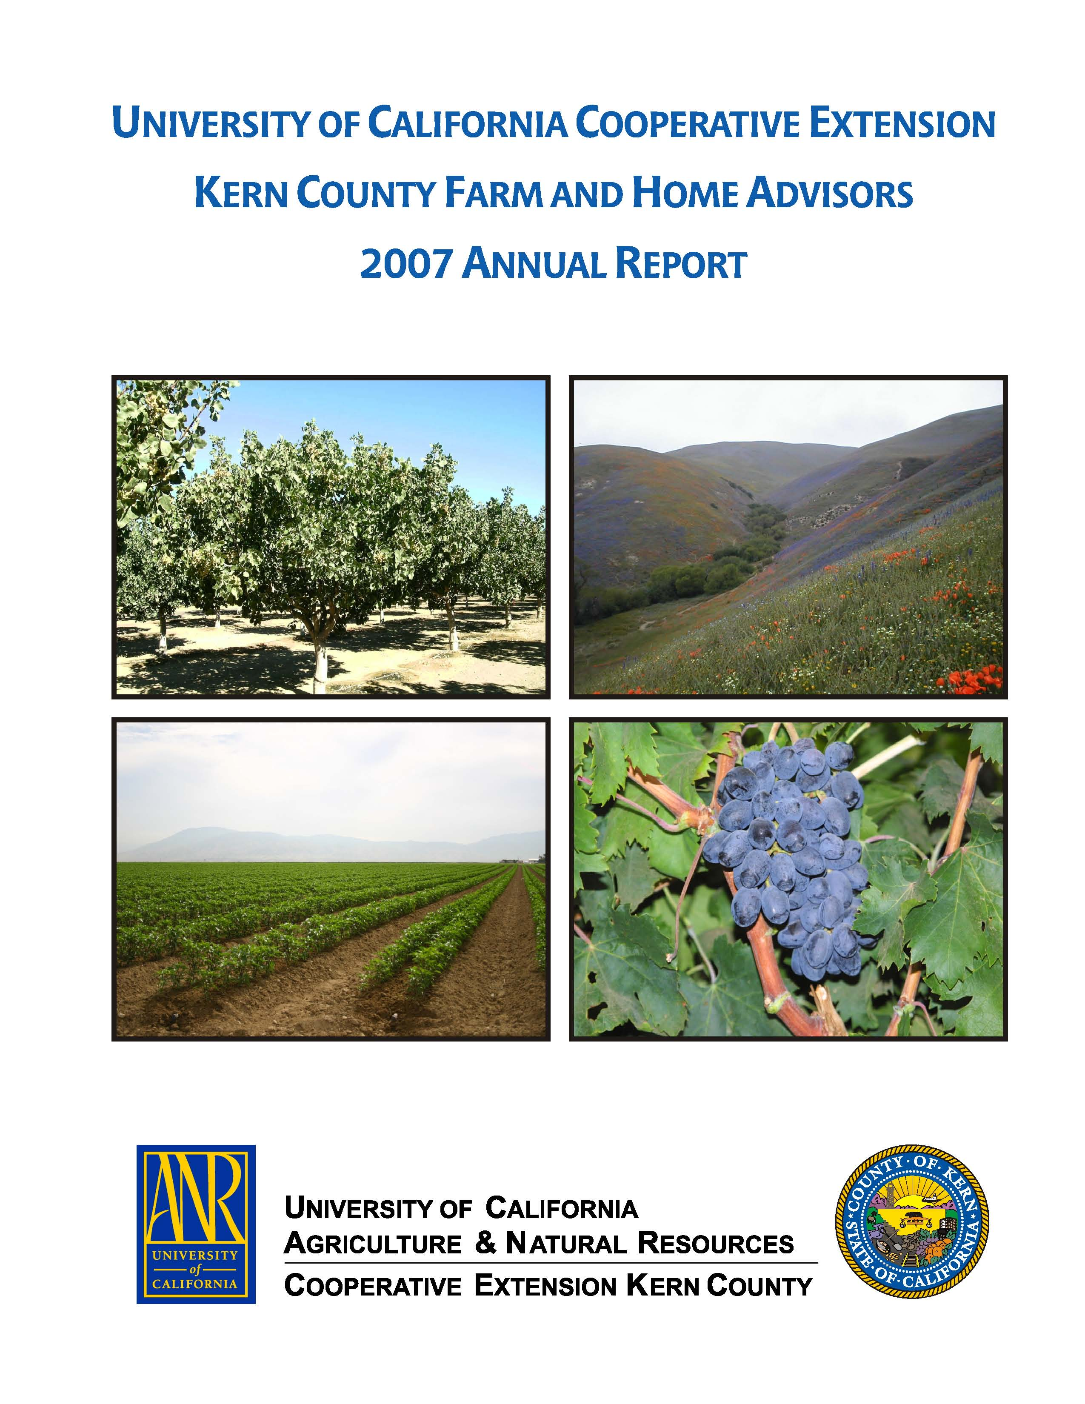
University of California Cooperative Extension
PISTACHIO NOTES
Kern County • 1031 S. Mt. Vernon Avenue • Bakersfield, CA 93307 • 661-868-6221

2010 ANNUAL STATEWIDE PISTACHIO DAY

Visalia Convention Center, 303 East Acequia - Visalia, California
Wednesday, January 13, 2010, 7:00 am - 12:30 pm
Registration begins at 7:00 am

Avoid the delay, frustration and EXTRA COST of registration on meeting day! Register online at http://fruitsandnuts.ucdavis.edu (under “What’s New”). Pre-Registration is $20. On site registration $25! Only checks or cash accepted on meeting day!

Agenda

7:00 a.m. REGISTRATION BEGINS: THOSE PAYING AT THE DOOR SHOULD COME EARLY TO AVOID DELAYS IN MEETING ATTENDANCE!

Moderator
Robert Beede, UCCE Farm Advisor, Kings County

8:00 a.m. Understanding the 2009 BOT Blowup: Management Guidelines for 2010
Dr. Themis Michailides, Plant Pathologist, KAC/UC Davis

8:30 a.m. Understanding Salinity and its Effect on Pistachio Plant Performance
Dr. Louise Ferguson, Pomology Specialist, KAC/UC Davis

9:15 a.m. Navel Orangeworm: Factors Affecting Survival, Pesticide Efficacy, and
Development
Dr. Joel Siegel, USDA-ARS, Entomologist, Parlier

10:00 a.m. Update on New Pistachio Varieties and Plantings
Craig Kallsen, UC Farm Advisor, Kern County

10:30 a.m. Break

Moderator
Elizabeth Fichtner, Farm Advisor, UCCE Tulare County

11:00 a.m. Diagnosis and Management of Alternaria Blight: A Resistance Challenge
Dr. Themis Michailides, Plant Pathologist, KAC/UC Davis

11:30 a.m. The Effect of Surround on Water Relations, Yield and Nut Quality
Blake Sanden, UC Farm Advisor, Kern County

12:00 p.m. Food Safety Challenges Facing the Pistachio Industry
Dr. Bob Klein, California Pistachio Research Board

12:30 p.m. ADJOURN

2.0 Hours of PCA and 3.0 CCA Hours of Continuing Education Applied For

