
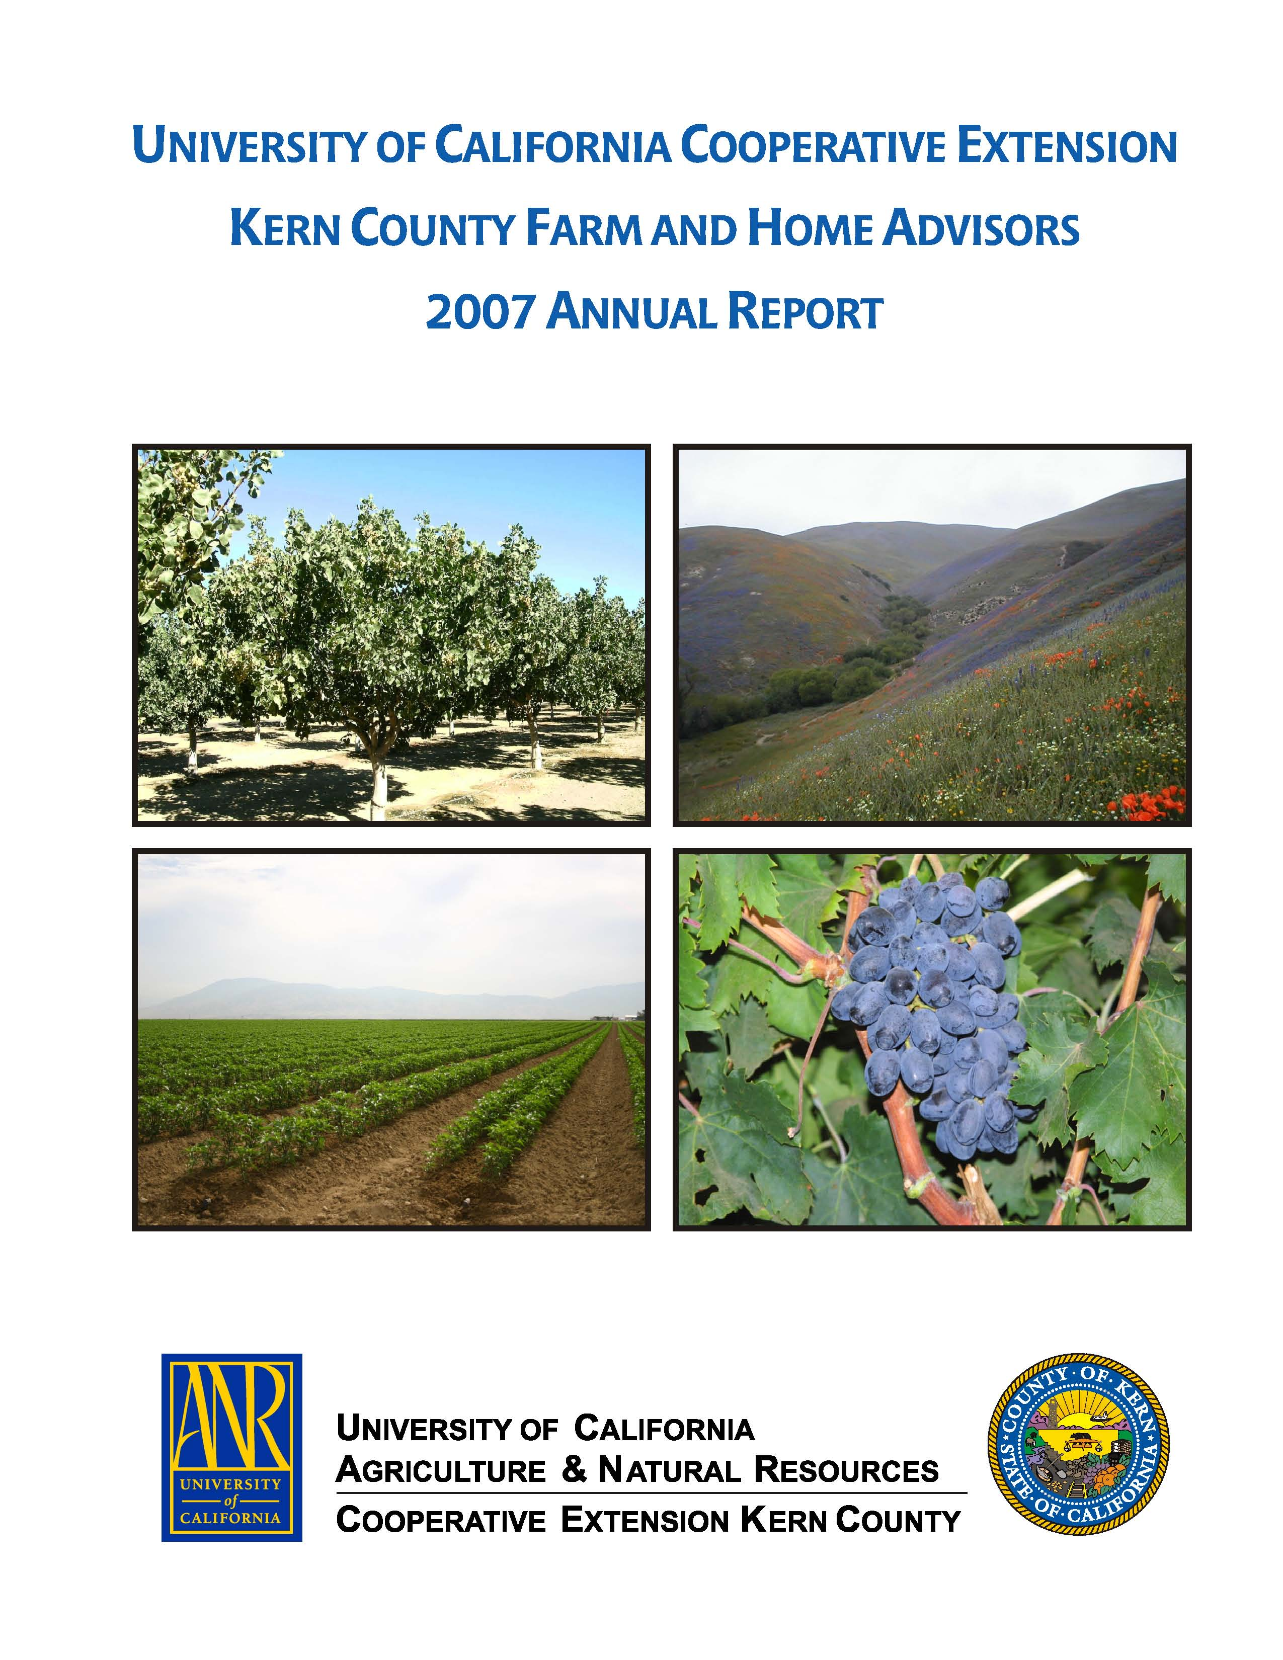
University of California Cooperative Extension
THE GREEN SCENE
Kern County • 1031 S. Mt. Vernon Avenue • Bakersfield, CA 93307 • 661-868-6220

July 2008

MASTER GARDENER I and IV CLASSES, FALL 2008
Perhaps the rise in gasoline prices offers an opportunity to stay closer to home and improve the lawn and landscape. UC Cooperative Extension, Kern County, plans to again offer classes in horticulture in autumn, 2008, covering the science and culture of landscape and garden plants. A Master Gardener I class will be offered Tuesday nights, 5:30-8:30 p.m., beginning August 26 and extending 16 weeks. Topics will include plant selection, soil science, landscape design principles, and pest management with an emphasis on organic and IPM methods, as well as sessions on vegetable crops, deciduous fruits, and citrus. A syllabus listing specific topics and session dates will be available in early August.
For those who want still more, a Master Gardener IV class is planned for Thursday nights, also 5:30-8:30 p.m., beginning August 28, also for 16 weeks. Topics will be additions to those covered in earlier MG classes, and will include landscape design as well as subjects pertaining to landscapes and the environment.
Classes will be held at the Cooperative Extension office, 1031 S. Mt. Vernon Ave. Cost of each class will be $70, continuing the price of recent years. We ask those interested in either class to call the Cooperative Extension office, 868-6200, to pre-register to reserve a space and help us track class size. Actual registration will be handled at the first meeting of the respective classes.

care and management of palms
A one-day meeting focusing on palm selection and care will be held Tuesday, September 9, at the UC Extension office auditorium, 1031 S. Mt. Vernon Ave. Topics will include species selection, UC research in transplanting palms including leaf tie-up and removal, palm nutrition and fertilizers, irrigation, palm diseases and miscellaneous disorders, and palm pruning. The speakers for this meeting will be three individuals from UC who specialize in palms, and among them have an extensive research record regarding these plants: Dennis Pittenger, area horticulture advisor from UCR, Don Hodel, author of a widely respected book on palms as well as more than 20 peer-reviewed research articles about palms, and Dr. Jim Downer, a plant pathologist with a specialty in palms. The program will begin at 8 am and include lunch. PCA hours will be available. This program will be held in conjunction with Abate-a-Weed, and registration will be handled by them. For more information about the program contact John Karlik, jfkarlik@ucdavis.edu or 661 868-6220, or for registration information contact Abate-a-Weed at 661 589-0615.

SAVING WATER IN LANDSCAPE IRRIGATION
Increases in water costs for the Bakersfield area may suggest re-evaluation of home landscape irrigation practices. For example, the new three tiered rate structure for urban water in the Bakersfield area from California Water Service Co. may result in sharp increases in home water bills. A new rate structure from that company took effect in early July, 2008, and in this article we use these rates (found at http://www.calwater.com/rates) as examples because much of the residential area of Bakersfield is subject to these rate provisions.
Water use requirements for plants in landscapes vary greatly by season, and can be expressed in terms of reference evapotranspiration (ETo), with units of inches per day. ETo is the amount of water needed to sustain unstressed cool season turfgrass, such as tall fescue. In spring, the historical value for ETo in the vicinity of Bakersfield is about 0.15 inches per day. This daily requirement does not mean that irrigation must occur everyday, but rather is a convenient accounting tool to estimate plant water use. In summer, the daily requirement increases to 0.25 (1/4) inches per day. In autumn, water use drops to 0.16 inches per day, and in winter, only 0.02 inches per day. Daily values may change significantly depending on temperatures and wind, but weekly averages for the southern San Joaquin Valley from May-September are consistent from year to year. Data for individual months are available, and current daily values for specific locations are available from California’s CIMIS network of measurement stations (http://www.cimis.water.ca.gov/).
The new tiered rate structure of California Water Service company has a lowest rate of $1.33 per CCF for the first 13 CCF. (Water usage on a monthly bill is often expressed as CCF = 100 cu ft = 748 gallons.) The next increment is $1.44 per CCF for the next 22 CCF, and then $1.68 for each additional CCF above these (in other words, above 35 CCF). Since the second tier water unit price is 8% per unit above the first tier, and the third tier price is 26% per unit above the first tier, we can see that upcoming water bills may show substantial increases over the past, especially for summer months when outdoor water use peaks.
Can we estimate landscape water use to see if irrigation savings may be possible? We can calculate how much water would be needed in a landscape, and as a starting point we consider 1000 sq ft of a landscape in summer irrigated at ETo, giving a value of 20.8 cubic feet per day. Assuming a 30-day month, this gives a value of 625 cu ft per month, or 6.25 CCF. One can see that the larger the landscape the larger the water needs, and irrigating just 2000 sq feet of a landscape at reference ETo brings us to the second tier of water rates. Of course, indoor use for cooking, showers, washing, etc., is also included in home water consumption, but if plants are overwatered landscape water use has the potential to cause substantial increases in home water bills.
It can be helpful to make simple measurements for assessing landscape water use. For example, placing several straight sided containers (such as coffee mugs) on a lawn while running the irrigation system, and then measure the depth of water in each to assess uniformity and application rate can tell us if we are considerably over-irrigating. In large landscapes such as golf courses, water application amounts per unit time are known and used to adjust clock settings.
Not all plants need to be irrigated at reference ETo. For example, studies at UC Riverside have shown that bermudagrass can be irrigated at 60% of ETo with little reduction in turf quality. Water requirements are well understood for agricultural crops and turfgrass species, but are not known precisely for most plant species grown in landscapes. Therefore, questions such as, “How many gallons per day are needed for my shade tree?” or, “How long should sprinklers run?” are difficult to answer.
To reduce overwatering, a simple approach is to irrigate until runoff occurs, and then check soil moisture between irrigations to adjust how often (how many days per week) sprinklers should run. Irrigation settings should be adjusted in combination with monitoring of soil between water applications. Monitoring may include checking soil dryness by probing with a screwdriver, soil tube, or shovel. Run-times may need to be increased in summer during extended periods of high temperatures. Every other day run-times will reduce water lost to evaporation.
Many other factors may affect how we manage irrigation at home, not the least of which is system design. Many home irrigation systems have very low uniformity, which would be intolerable in an agricultural setting or on a golf course. Irrigation system efficiency and scheduling can be as significant as landscape size in affecting water use and the water bill.
Seasonal changes in water needs suggest irrigation settings should be altered at least four times per year. The advantages of quarterly adjustment of irrigation are several. Too little water results in stress to plants, which may result in aesthetic injury, such as brown margins of leaves. A subtle but more damaging effect of water stress is increased susceptibility to wood borer attack, especially for fruit trees. Conversely, too much water can lead to root disease and weed invasion. Changing the frequency of irrigation rather than its duration is preferable for making seasonal adjustments. Each irrigation should wet soil to the rooting depth of plants, if possible. In other words, increasing or reducing the number of days irrigation occurs will adjust applied water to match plant needs.

John Karlik
Environmental Horticulture/Environmental Science

The University of California prohibits discrimination or harassment of any person on the basis of race, color, national origin, religion, sex, gender identity, pregnancy (including childbirth, and medical conditions related to pregnancy or childbirth), physical or mental disability, medical condition (cancer-related or genetic characteristics), ancestry, marital status, age, sexual orientation, citizenship, or service in the uniformed services (as defined by the Uniformed Services Employment and Reemployment Rights Act of 1994: service in the uniformed services includes membership, application for membership, performance of service, application for service, or obligation for service in the uniformed services) in any of its programs or activities. University policy also prohibits reprisal or retaliation against any person in any of its programs or activities for making a complaint of discrimination or sexual harassment or for using or participating in the investigation or resolution process of any such complaint. University policy is intended to be consistent with the provisions of applicable State and Federal laws. Inquiries regarding the University’s nondiscrimination policies may be directed to the Affirmative Action/Equal Opportunity Director, University of California, Agriculture and Natural Resources, 1111 Franklin Street, 6th Floor, Oakland, CA 94607, (510) 987-0096.



