
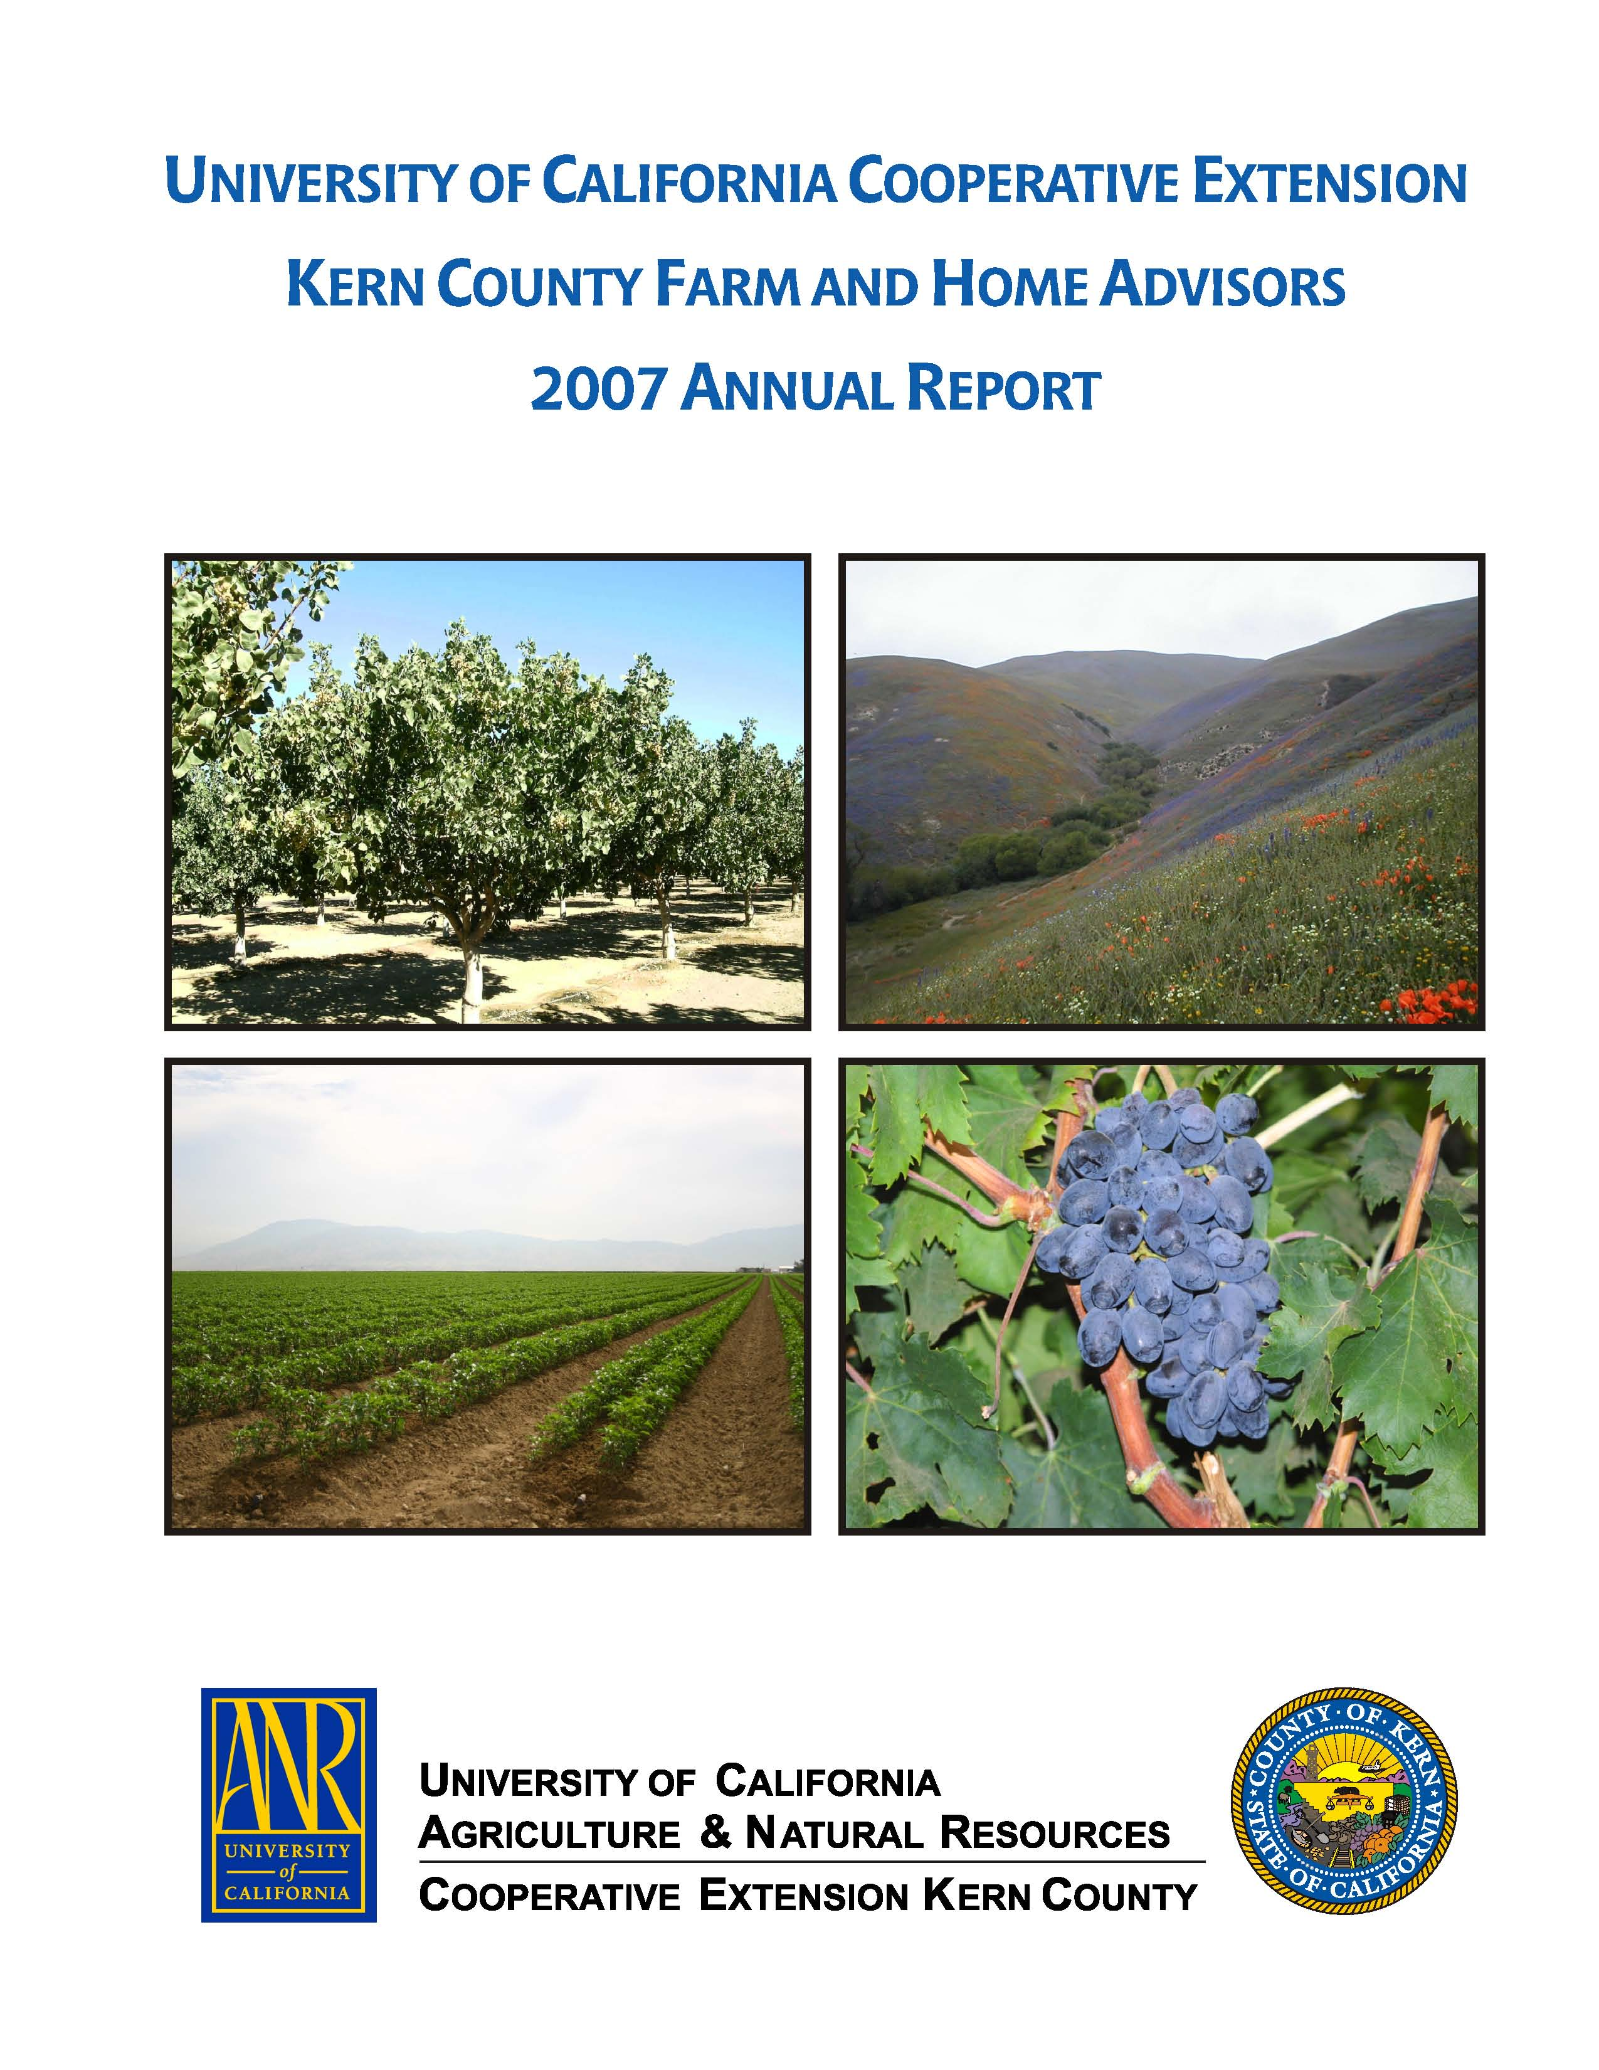
University of California Cooperative Extension
THE GREEN SCENE
Kern County • 1031 S. Mt. Vernon Avenue • Bakersfield, CA 93307 • 661-868-6220

June 2008

Water Conservation at Home: A Case Study
Water remains perhaps the most limiting natural resource in the southwestern United States. As California’s population continues to increase, the demand for water will increase as well. Although agriculture dominates use of developed water statewide, in urban areas about half the water is used outdoors, and of that fraction about half is used for landscape irrigation. That’s a large component of total water use in Los Angeles and other urban areas. Homeowners may be interested in saving money on water bills, improving plant health, limiting weeds, and being ecologically responsible while still having an attractive, low-maintenance landscape.
There are several modifications that can reduce water use in landscaped areas. Some are relatively simple, such as adjusting irrigation schedules. Others require more cost and time, such as replacing some plant materials with others or rearranging an irrigation system.
I did a case study a few years ago in a house I owned to see how much various changes in the landscape affected water use. Some modifications, particularly correlating the amount of water needed by the yard with the amount applied, reduced water use much more than others.
Escrow closed in November of what I’ll call year one, and I immediately began a four-phase plan to change the landscape and evaluate water use. Goals were to minimize maintenance, lessen the need for herbicides and insecticides, conserve water and evaluate some plants infrequently seen around Bakersfield. I tracked water use through monthly water bills, which also showed water use by the previous owner.
The first phase focused on assessing the property. The yard had 4,880 square feet total of well-maintained hybrid bermudagrass with additional area of border plantings of annual flowers and shrubs. The yard was watered with a combination of fan sprays, impact heads and a few drip lines in border areas.
Phase two was to begin to reduce unnecessary water use on the landscape that came with the house. I began by conducting a water audit, a simple task that consisted of placing small containers around the yard and measuring the amount of water in the containers after a watering cycle. I used these data to determine precipitation rate; that is, how much water sprinklers delivered per given time period. Then, I checked UC reference data for historic evapotranspiration rate (ETo), which gave the amount of water an unstressed area of turfgrass uses per day. From January to October of year two, watering frequency and duration were adjusted based on the water audit with turf irrigated at approximately 60 percent of ETo. Bermudagrass can be watered at this amount and without a loss in appearance. After October, the irrigation system was shut off for winter. The water audit plus changing sprinkler time settings based on ETo was one of the least expensive alterations in reducing water use, yet one of the most effective. This simple change of applying as much water as the lawn needed resulted in a 33% savings in outdoor water use for year two compared to year one.
In phase three, bermudagrass was replaced and the total turf area reduced. Bermudagrass was treated with two applications of glyphosate at the label rate. I then cut and removed the dead turf, and replaced it with ‘El Toro’ zoysia, a UC turfgrass release. The new turf was laid as dormant sod in December. The main reason for turf replacement was not water conservation, at which bermudagrass excels, but rather to reduce maintenance and to observe ‘El Toro’ in a residential setting, since at the time ‘El Toro’ was quite new. The bermudagrass on the south side of the driveway was replaced with plants from an Arizona nursery thought to be water conserving. In the side yard along the street, bermudagrass between a fence and sidewalk was replaced with landscape roses watered by drip irrigation. The new turf area was 3,260 square feet, 67% of the original turf area. Water saving following these modifications was small, only 4% less than in year two.
In year three, the final phase of landscape modification occurred. From January through March, front-yard irrigation valves were moved closer to valves for the backyard irrigation. This allowed turf lines and drip lines to be run on separate schedules without buying more expensive clocks. The drip irrigation system was expanded in the front foundation planting and drip irrigation was installed for hybrid tea roses along the back fence. Water use in the landscape decreased 16% in year three compared to year two. This decrease can be attributed to zoning of irrigation, which allowed turf lines and drip lines to be run on separate watering schedules. Also, and an important factor in that particular year, heavy spring rains allowed a two-month delay in the beginning of the irrigation season.
Overall, by these modifications, water use in the landscape was reduced to 55% of its initial value. As noted, the greatest savings occurred by simply adjusting clock settings to better correspond to plant water needs. Other benefits were reduction in maintenance time and improved ease of care of the landscape.

Poison Oak
Poison oak is common along the Kern River and in the foothill areas. In spring 2008, shrubs of poison oak seem to be exceptionally vigorous in growth.
How is poison oak recognized? It is one of the most common shrubs in the woodland understory below 4,000 feet elevation in California. The plant has three leaflets, the upper surface darker than the lower. The middle leaflet is most likely to look like an oak leaf, but plants can be found with smooth leaf margins. Beyond these characteristics, the plant form and shape of the leaves is extremely variable. In open fields, the plant grows as a spreading clump up to about five or six feet high. It may appear as a low groundcover a foot tall in arroyos. It sometimes wraps around trees or poles and can grow 20 or more feet high. Flowers, when present, are greenish-white and about a quarter inch across. They are found in cluster originating in the angle (axil) where the leaves are attached to the stem. A white berry cluster matures and may hang into the winter, and fall color of leaves is red to maroon. Without leaves, the stems appear gray-black and are often covered with fine hair.
An estimated 100 million Americans are sensitive to the chemicals in poison oak and related eastern cousins, poison ivy and poison sumac. The toxicant is a compound called urushiol, a group of four closely related oils produced in the resin ducts of the plant. William Epstein, a national leader in poison oak research at University of California Medical Center in San Francisco, has developed a skin test to measure an individual’s sensitivity. Epstein stated, “between 15 and 25 percent of us are essentially immune, 25 percent are mildly sensitive and don’t develop severe reactions, 25 to 30 percent are moderately sensitive and break out significantly with the amount of urushiol found in one leaf, and 10 to 20 percent are so exquisitely sensitive that less than one leaf produces intense dermatitis.” Similar to other allergies, we are born without sensitivity to urushiol, but most people acquire sensitivity by contacting plants as children.
Poison oak is not a true oak, but is a member of the cashew family. Poison ivy and poison sumac, not found in California, also are members of the cashew family and contain the same oil. Recent research says that physical contact with the oil is necessary for skin rash to develop. Urushiol has a low vapor pressure and therefore does not evaporate easily. Pollen does not contain the oil, but leaves and stems do. The oil can be transferred through contact to clothing, equipment, or fur of animals and produce the same skin reaction through later contact. The oil is carried on particles of soot when the plant is burned and is a serious health hazard during forest fires.
Within minutes of skin contact urushiol molecules bind themselves to proteins in skin cells. Washing with cold water immediately after contact will wash off any oil that has not already bonded to skin. Once attached to skin, urushiol causes an allergic reaction. Symptoms may take a few hours or up to a week to appear, as the body sends armies of white cells to destroy the skin cells with the invader. The white cells release so many cell destroying toxins that skin blisters and oozes. The plasma released from the skin cannot spread the rash – it is just body fluid – but scratching can lead to infection. Household remedies may help, but so does the familiar calamine lotion. Burow’s solution, sold without a prescription under a trade name, may also be helpful.
It is best to avoid contact with any plant part. On small properties poison oak plants can be destroyed by cutting and treating stems with a herbicide, such as glyphosate. A few herbicides will kill the plant outright, but urushiol within the dead stems will take time to degrade. One must be aware of tools, clothes or gloves that have had contact with the plant, and clean them thoroughly before re-use. If plants are burned, one should avoid facial contact or breathing of smoke.

Ants
Ants are perhaps the most common household insect pest in Kern County, with favorable weather and climate for colony development of several species. Ants can also be found in landscapes, often more as a nuisance to humans than as a damaging insect to plants. Arrival of summer and warmer weather allows ants to reproduce rapidly and colonies to increase in size. Development of improved ant baits has helped in managing these insects.
A useful reference regarding ant biology and control are several files on the UC IPM website, http://www.ipm.ucdavis.edu. Much of the background information for this newsletter article has been excerpted from the Pest Note “Ants” (Klotz and Rust, 2007) found on that website.
Ants are social insects of the order Hymenoptera, the same insect order containing bees and wasps. Like bees, the duties within an ant colony are divided among different groups or castes, workers being the most numerous. The queen remains protected in the colony and produces eggs, which pass through complete metamorphosis of larva, pupa and adult. Unlike termites, ants have a thread-like waist and antennae with an elbow rather than straight. Of the two hundred or so species found in California, fewer than a dozen are important pests, and in Kern County most ant problems are caused by only two species, Argentine ant (Linepithema humile) and southern fire ant (Solenopsis xyloni). Argentine ants are common household pests, while southern fire ants are found mostly outdoors. Argentine ants are unusual in that a colony has multiple queens and workers from one location are welcomed elsewhere. Thus, Bakersfield is essentially one supercolony of Argentine ants. Southern fire ants (not the same as the imported fire ant of Texas, and more recently Southern California), are recognizable by their stings when crawling on exposed skin.
Ants need food, water, and shelter. Outdoors, food sources for some species include honeydew secreted by aphids and soft scales. Reducing aphid populations may limit the food source and hence the colony size. It is, however, impossible to completely and permanently eliminate ants from a landscape, and to do so would be counterproductive, since ants perform useful scavenging functions, feeding on dead insects and animals. Since neither very wet nor very dry conditions are favorable for ants, it should be no surprise that an irrigated landscape, with its combination of wet and dry soil conditions, provides very favorable conditions for ant colonies. Occasionally, ant colonies may be found in potted indoor plants or in planter areas, especially if the planter area has contact with soil beneath the house. Colonies may also be found underneath concrete slabs with access into houses through cracks in the slab or via expansion joints in a garage. Partly depending on species and time of year, ants may prefer sugary foods, oils, or protein such as meat. Kitchens are sources of all of these, so ants may discover via scouts a food source and quickly build a trail to the colony.
Management of ants includes familiar principles of IPM, including exclusion and sanitation. Caulking cracks and sealing openings into houses is helpful. Cleanup of food residues and countertops leaves less source material for ants to find. Because ants leave behind and follow chemical scents to form a trail, cleanup of trails with soap disrupts the procession and ants must rediscover food sources.
What about limiting ant numbers with insecticides? Household aerosol sprays often contain pyrethroids, which are fast-acting but short-lived compounds. These can be used when an ant trail is discovered and provide quick knockdown (be sure to follow label directions with any insecticide product). However, worker ants are easily replaced by the colony. To limit intrusion by ants, a perimeter spray around a dwelling may be helpful, and is something a pest control service can provide. The barrier will be temporary since insecticides break down. Whether or not a perimeter treatment is made, it is possible to reduce ant numbers with baits. These materials are a big improvement in terms of both effectiveness and environmental safety compared to products available ten years ago. (Formerly, one could search for the ant nest and attempt to eliminate it with contact insecticides. However, removing even 90% of the workers would not be effective since the queen was well protected and new workers would be produced.) The newer ant baits, containing insecticides such as hydramethylnon, fipronil, or sulfluramid, are slow acting with very low toxicity to mammals as formulated products. They can be included in either protein or sugar baits. After feeding, workers transmit the active ingredient to the queen, leading to collapse of the colony. Ant baits should be used according to label directions, and the bait material selected as to the food preferences of the ant in question (sugar or protein-feeding, for example). The insecticides in the baits can be degraded rapidly by sunlight and to a lesser extent by water, so application in shaded, dry areas, or application in the evening can allow more time for workers to find bait granules and carry them back to the nest. Placing a little bait in an ant runway will result in workers congregating and feeding almost immediately if bait is desirable to the ant. Since colonies typically increase in size over the summer, ant problems tend to become worse as we enter autumn. Repeat applications of baits, as needed, can limit these nuisance insects. Please note that ant insecticides containing pyrethroids, such as bifenthrin or lamda-cyhalothrin, are short-lived contact materials, and will not be effective as baits. Although ant insecticides are widely available, the more effective bait products may not be available at the big box home stores; however, specialty turf and landscape stores often carry them.

Master Gardener Classes
For those who have asked, UC Cooperative Extension, Kern County, is likely, at the 80th percentile of confidence, to offer classes in horticulture in autumn, 2008. I expect we will offer a Master Gardener I class and, for those who haven’t yet had enough, a Master Gardener IV class. I appreciate the interest shown in Master Gardener classes in past years. Please contact me in late July for the start times. I will also send an announcement via my newsletter, and ask Joan Swenson to place an announcement in her column.

John Karlik
Environmental Horticulture/Environmental Science

The University of California prohibits discrimination or harassment of any person on the basis of race, color, national origin, religion, sex, gender identity, pregnancy (including childbirth, and medical conditions related to pregnancy or childbirth), physical or mental disability, medical condition (cancer-related or genetic characteristics), ancestry, marital status, age, sexual orientation, citizenship, or status as a covered veteran (covered veterans are special disabled veterans, recently separated veterans, Vietnam era veterans, or any other veterans who served on active duty during a war or in a campaign or expedition for which a campaign badge has been authorized) in any of its programs or activities. University policy is intended to be consistent with the provisions of applicable State and Federal laws. Inquiries regarding the University’s nondiscrimination policies may be directed to the Affirmative Action/Staff Personnel Services Director, University of California, Agriculture and Natural Resources, 1111 Franklin Street, 6th Floor, Oakland, CA 94607, (510) 987-0096.

