
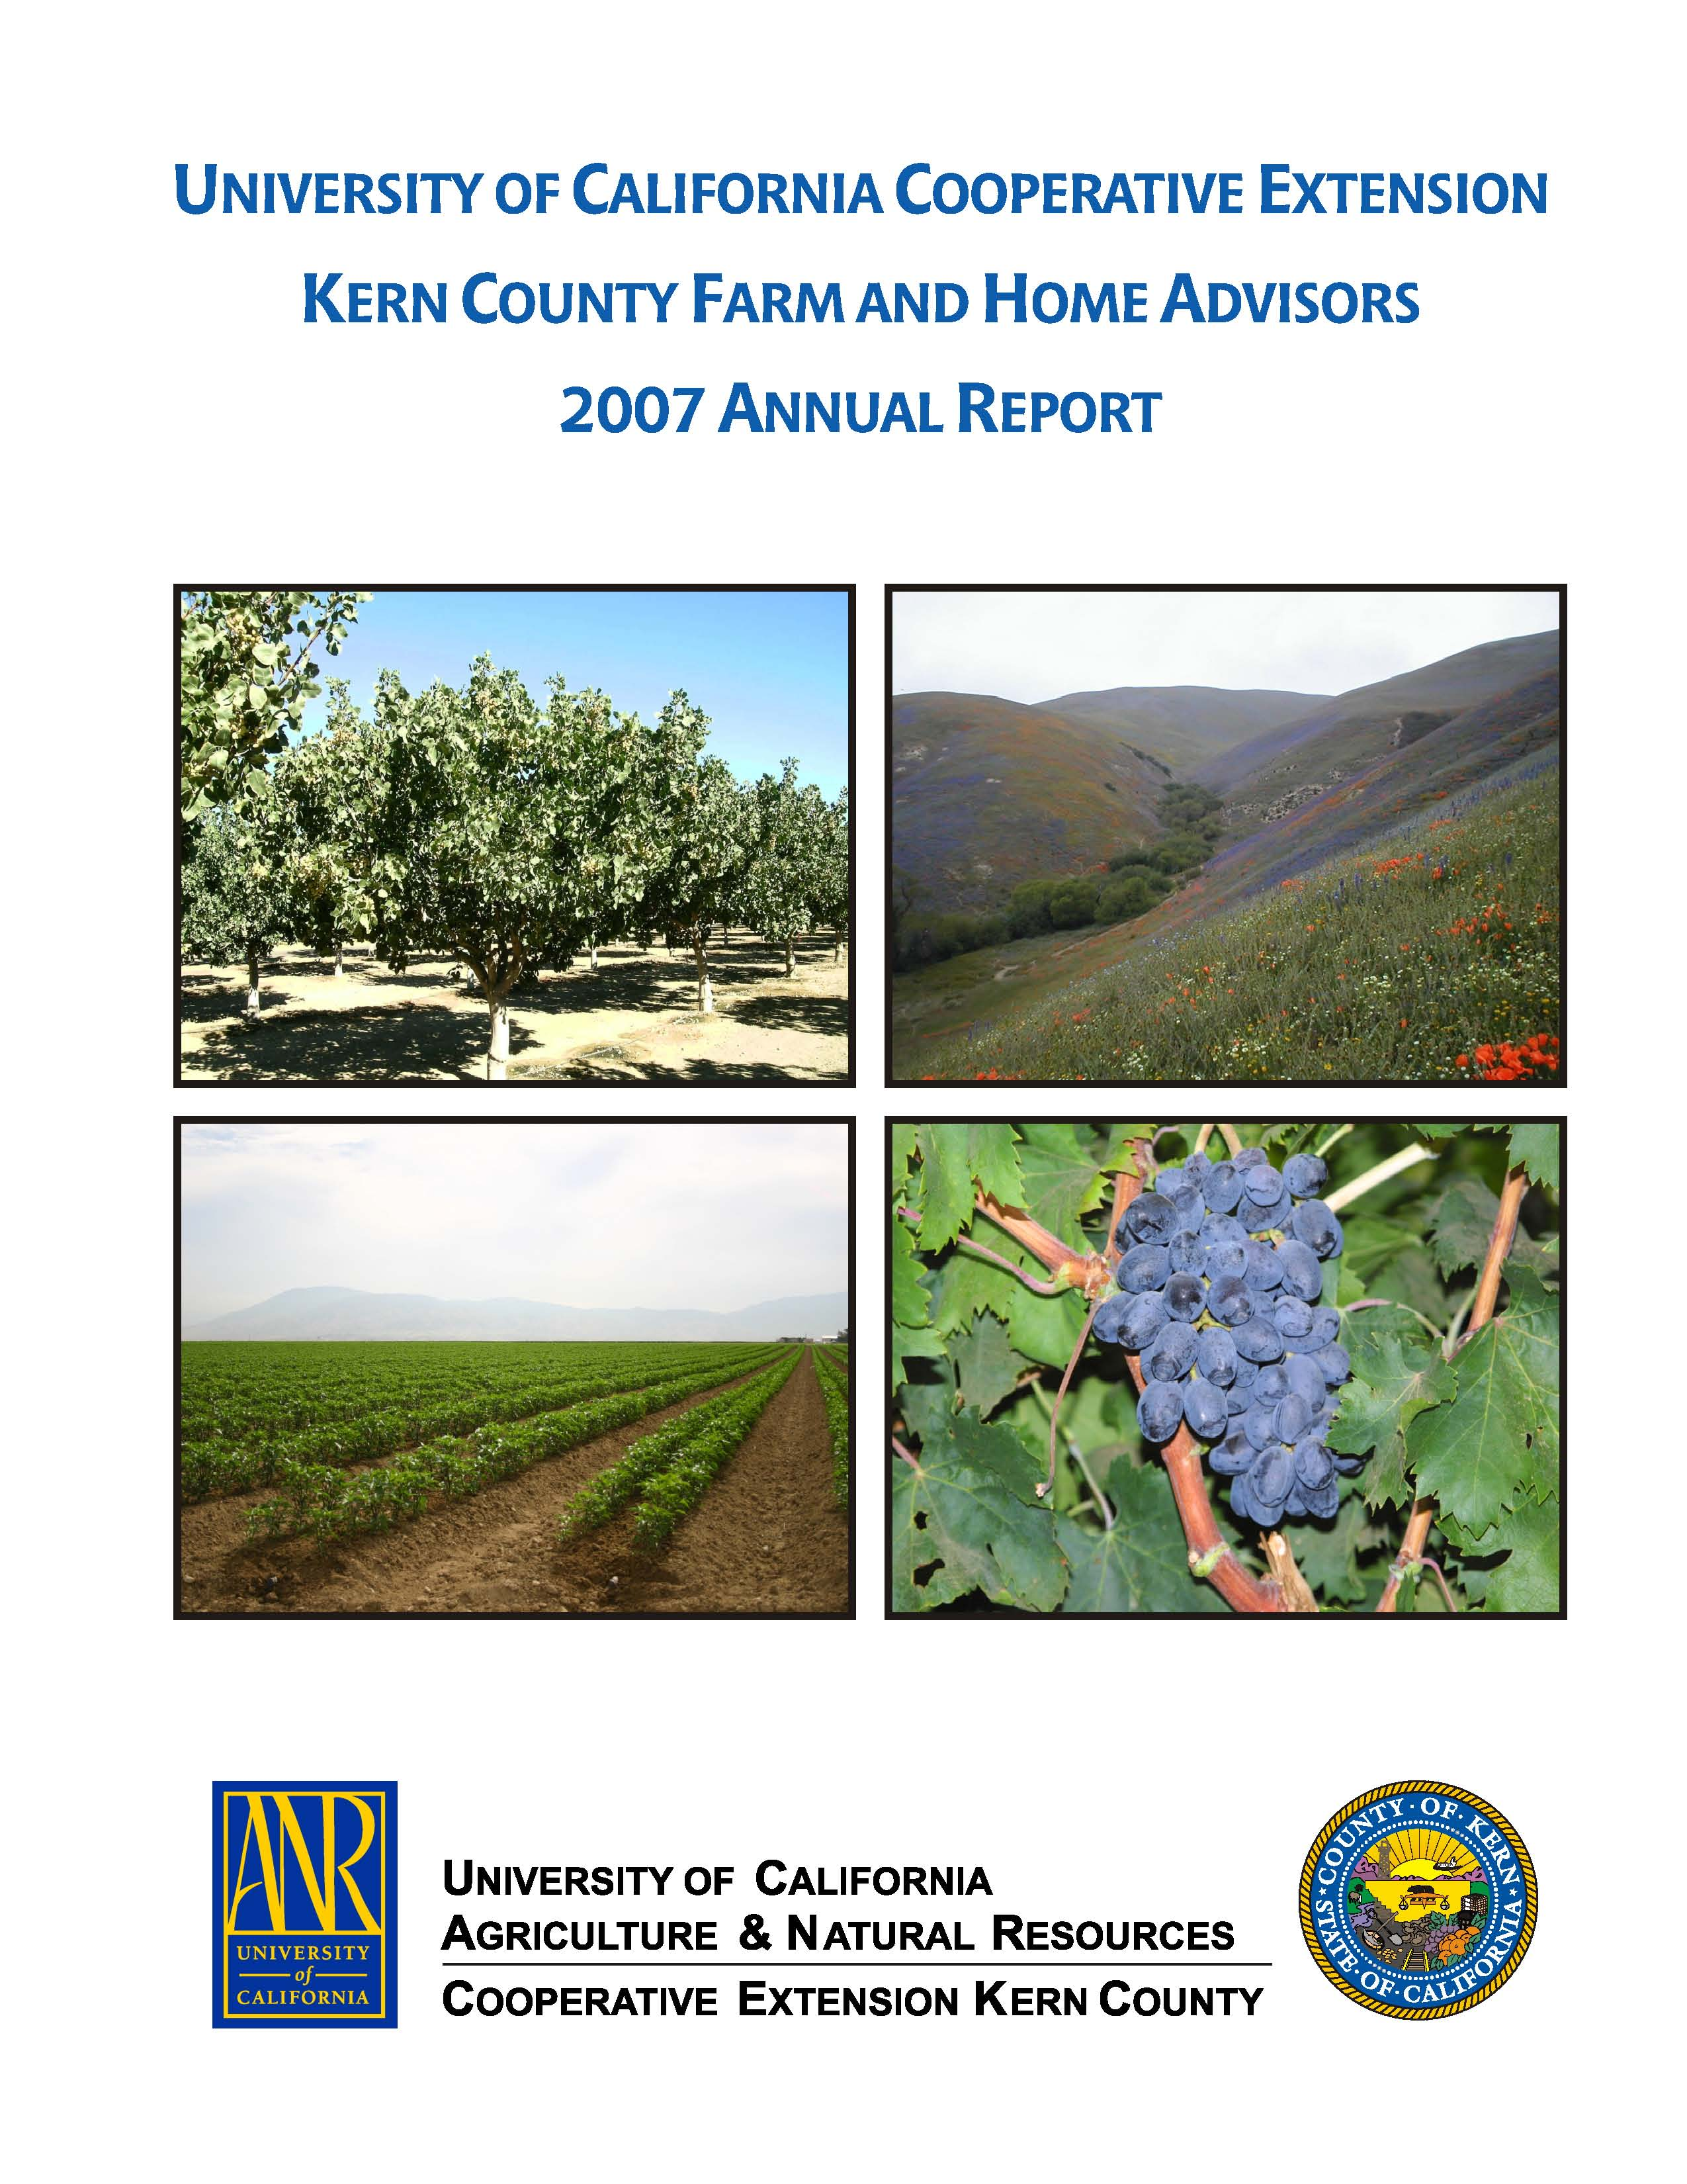
University of California Cooperative Extension
FROM THE VINE
Kern County • 1031 S. Mt. Vernon Avenue • Bakersfield, CA 93307 • 661-868-6223

GRAPE INTEGRATED PEST MANAGEMENT ISSUES
Kearney Agricultural Research and Extension Center
9240 S. Riverbend Avenue, Parlier CA
Monday, June 28, 2010 at 12:00‐4:00pm

12:00‐12:30pm
Registration

12:20pm
Welcome
Stephen Vasquez, University of California Cooperative Extension, Fresno County

12:45‐1:30pm
Spiders, Scorpions and Snakes
Michael Glassey
All‐Pro Environmental Services and Pest Control

1:30‐1:50pm
Some Spray Tips for Aiding Herbicide Performance in Grape Vineyards
Kurt Hembree
University of California Cooperative Extension, Fresno County

1:50‐2:10pm
Mating Disruption for Lobesia botrana (EGVM) Control in Italy’s Table Grape Vineyards
Michele Melillo
Agriproject Group s.r.l., Italy

2:10‐2:30pm
An update on European Grapevine Moth (Lobesia botrana) in the San Joaquin Valley
Walt Bentley
University of California Integrated Pest Management, Kearney Ag Center

2:30‐3:15pm
Board Trams and depart for field.

3:00‐4:00pm
Table Grape Trellis Installation
D & S Ag Designs: http://www.dandsagdesigns.com/

4:00‐4:15pm
Board Trams and depart for parking lot and buses.

CE and CCA units pending.
Meeting includes: meeting, proceedings and lunch.

ONLINE REGISTRATION: http://ucanr.org/grapepestmanagement

University of California Cooperative Extension
FROM THE VINE
Kern County • 1031 S. Mt. Vernon Avenue • Bakersfield, CA 93307 • 661-868-6223

TABLE GRAPE PLANT GROWTH REGULATOR WORKSHOP
Visalia Convention Center, 303 E. Acequia, Visalia, CA 93291
Tuesday, June 29, 2010

10:00am Registration
10:45‐11:00am Welcome and Introductions

11:00 to 11:15
The potential benefits or demerits of using gibberellic acid for thinning and sizing some of the important new seedless table gape varieties.
Jennifer M. Hashim, UC Cooperative Extension Viticulture Farm Advisor, Kern County
1031 S. Mt. Vernon Avenue, Bakersfield, CA 93307 USA

11:15 to 11:30
The use of CPPU by table grape growers in South Africa; varieties treated, typical use rates, and effects on berry quality.
Pieter Raath, Lecturer
Department of Viticulture and Oenology, Stellenbosch University, Stellenbosch, South Africa

11:30 to 11:45
Ethephon for improving the color of red and black table grapes
William Peacock, UC Cooperative Extension Viticulture Farm Advisor, Emeritus
Tulare County, USA

11:45 to 12:00pm
The use of S‐ABA (ProTone™) for improving the color of table grapes.
Mr. Rob Fritts, Jr, Technical Development Specialist
Valent BioSciences Corporation, 870 Technology Way, Libertyville, IL 60048, USA

12:00 to 12:15
Experimental work toward the development of abscission agents for producing individual table grapes.
Giuseppe Ferrara, PhD, Assistant Professor
Dipartimento di Scienze delle Produzioni Vegetali, University of Bari, Bari, Italy

12:15 to 12:30
Moderated question and panel discussion
Matthew Fidelibus, PhD, Cooperative Extension Viticulture Specialist
Department of Viticulture and Enology, University of California, Davis, CA, USA

CE and CCA units pending.
Meeting includes: meeting, proceedings and lunch.

REGISTER ONLINE: http://ucanr.org/tablegrapeworkshop

