
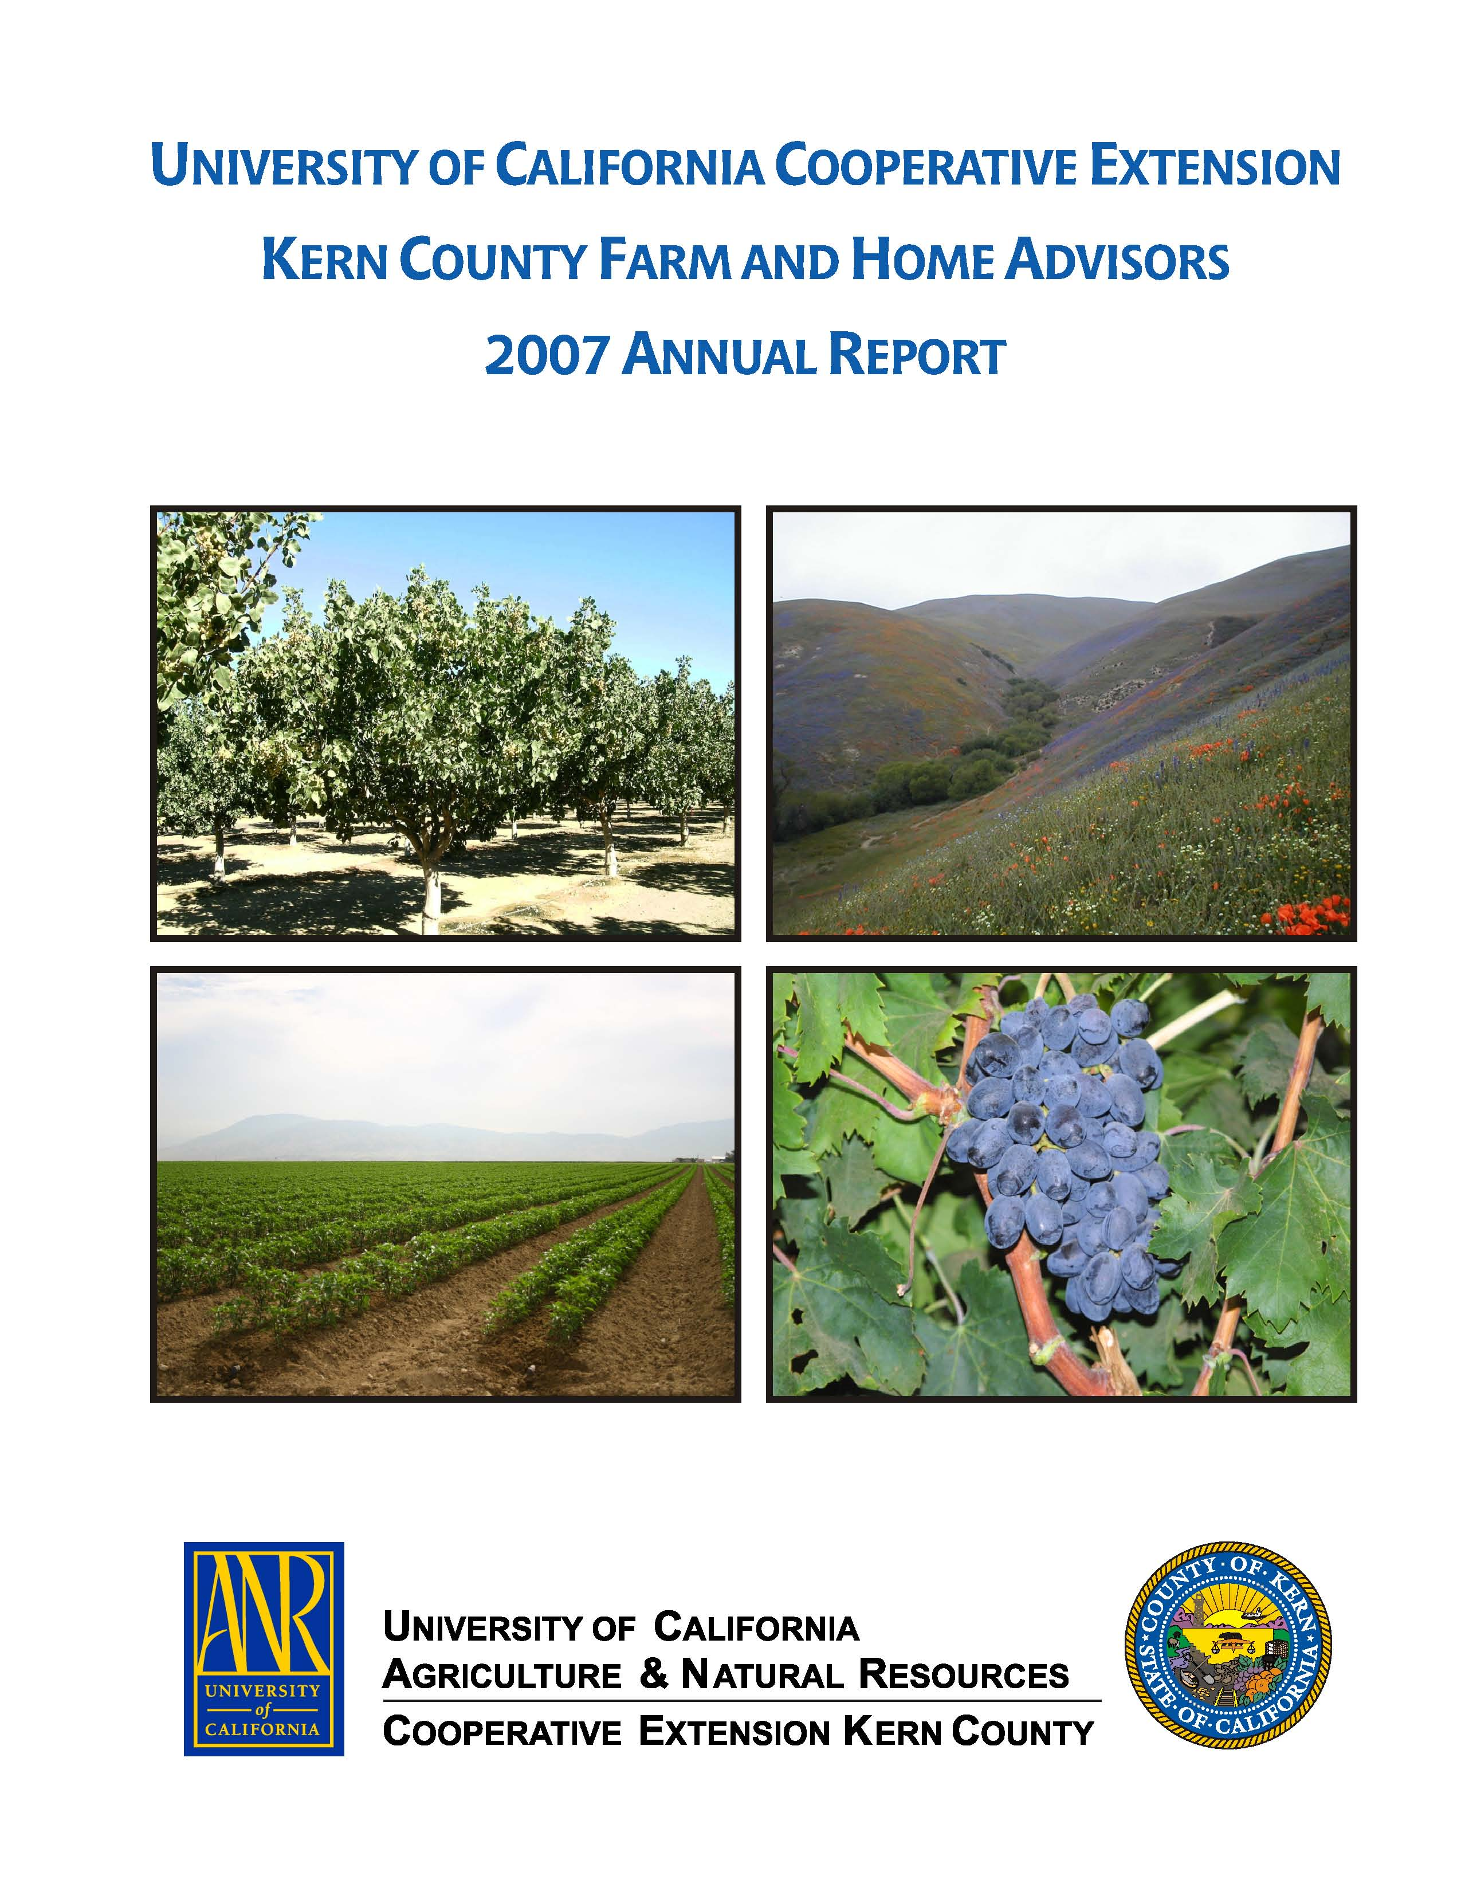


University of California Cooperative Extension
KERN VEGETABLE CROPS
Kern County • 1031 S. Mt. Vernon Avenue • Bakersfield, CA 93307 • 661-868-6222

Fall 2008
2008 Kern County Processing Tomato Variety Trial

The Kern County Processing Tomato Variety Trial is part of the UC Uniform Statewide Processing Tomato Variety Trial in which the same trial is conducted throughout the processing tomato production areas. This allows the UCCE to determine which processing tomato varieties work well in each area.
This year’s trial was conducted in a grower’s field. Over the winter, we where able to obtain a one row transplanter that we rebuilt and used to transplant the young seedlings. We were also able to locate a used GT cart that we converted into a weigh wagon so that we could weigh our tomato yields in the field as we harvested.
The trial was composed of all mid-maturity processing tomato varieties which was planted on March 23, 2008. Five pound samples were taken of red fruit and sent to the local PTAB station for color, solids, and pH analysis. We harvested the trial on August 26, 2008.
The standard varieties were AB 2, H 2601, and H 9780. The results show that SUN 6368, H 9780, NDM 5578, and H 2005 performed very well (Table 1). The standard H 9780 showed why it is a standard by producing a yield of 34.1 tons/A. Most of the varieties actually performed very well with no real low yielding varieties.
But looking at the observational varieties, there appears to be some excellent varieties coming on board soon (Table 2). NUN 6385 and NUN 6390 performed exceptionally well at over 48 tons/A each.

Table 1. Results for the 2008 Kern Replicated Processing Tomato Variety Trial.

Variety | Tons/a | Color | Solids | pH
1. AB 2 | 28.5 | 4.0 | 25.75 | 4.45
2. AB 8058 | 29.9 | 3.8 | 25.25 | 4.60
3. H 2005 | 31.5 | 5.3 | 23.75 | 4.60
4. H 2601 | 24.2 | 4.6 | 25.00 | 4.64
5. H 4007 | 27.9 | 4.4 | 22.50 | 4.65
6. H 8004 | 26.1 | 5.0 | 25.00 | 4.51
7. H 9780 | 34.1 | 5.0 | 24.50 | 4.48
8. HM 6898 | 28.8 | 4.4 | 25.50 | 4.51
9. NDM 5578 | 32.3 | 4.3 | 24.25 | 4.57
10. NUN 672 | 25.4 | 3.9 | 24.25 | 4.62
11. PX 1723 | 26.5 | 4.8 | 24.50 | 4.59
12. SUN 6368 | 38.7 | 4.7 | 25.50 | 4.50
13. UG 4305 | 26.5 | 3.7 | 25.25 | 4.64

Table 2. Results for the 2008 Kern Observational Processing Tomato Variety Trial.

Variety | Tons/a | Color | Solids | pH
BOS 1411 | 37.4 | 23 | 5.1 | 4.50
CXD 255 | 39.2 | 22 | 5.6 | 4.47
CXD 269 | 32.4 | 23 | 5.4 | 4.54
DRI 0303 | 30.4 | 26 | 4.1 | 4.52
H 8504 | 34.5 | 26 | 4.5 | 4.42
HMX 7885 | 39.1 | 24 | 4.0 | 4.76
NUN 6385 | 48.8 | 24 | 4.1 | 4.50
NUN 6390 | 48.1 | 26 | 4.0 | 4.52

California Potato Research Advisory Board
2008 Annual Report

The variety trial was composed of several different variety trials combined to form the Kern County Potato Variety Selection and Development Trial. The Southwestern Regional Trial is made of varieties developed by breeders from Colorado State and Texas A & M Universities and tested in those states along with California. This year’s Southwest Trial contained 35 entries, much larger than normal. In fact this trial has been increasing in size the last three years. We asked that this trial be scaled back to its original size as it was becoming too large to manage. The Kern County Trials are made up of primarily of varieties developed by university and USDA breeders. An effort was made this year to obtain varieties from sources normally not used. We included material from the University of Minnesota, Michigan State University, and Cornell University. The varieties in the Kern County Replicated Trial were selected by the Potato Variety Trial Advisory Committee from varieties chosen from last year’s Kern County Observational Trial. The Kern County Observational Trial is made up of material we receive from US and Canadian breeders to see how they perform in Kern County. This trial is not replicated but made up of just one 20-ft plot. If it does well this year it may move up to the Kern County Replicated Trial the following year.
This year for the first time we conducted the Snack Food Association Chip Trial. I was approached by the trial coordinator, Donald Halseth of Cornell University, and asked if I would be willing to conduct the SFA Chip Trial in Kern County. I checked with chip growers in Kern County and they were supportive of a chip trial.
The trial was planted 2/15/08 in a grower’s field. All of the trials were replicated four times in a randomized complete block design except for the Kern County Observational Trial which just had one entry for each variety. All of the plots were composed of 27 seed pieces planted in 20-ft rows. The entire trial was planted by opening up the beds with an empty 2-row planter, dropping the 27 seed pieces for each plot by hand, and then covering the seed and reforming the beds with a 2-row cultivator. Otherwise, all normal grower practices were followed.
The trial was harvested on 6/9/08 with a one- row potato digger that undercut the plants, lifted the tubers and dropped the tubers onto the ground. The tubers where picked up by hand and placed into burlap bags for grading. Once graded, the tubers were washed in a portable potato washer, re-bagged, and then stored in cold storage until the potato field day held on 6/19/08.

Results:

Southwest Regional Trial
The Southwest Regional Trial had several excellent new varieties. The standards Red LaSoda yielded 438 cwt/A, Russet Norkotah 204 cwt/A, and Dark Red Norland 204 cwt/A. By comparison the russet varieties #6. AOTX96216-2Ru, #8. AC99375-3Ru, and #13. AOTX98152-3Ru yielded 394, 329, and 382 cwt/A respectively. That is from 125 to 190 cwt/A more than Russet Norkotah. Outstanding red skinned varieties were #21 BTX2332-1R and #25 AOTX93483-1R with 375 and 353 cwt/A respectively. The yellowed fleshed varieties #30 CO00412-5W/Y yielded 327 cwt/A, #31 ATC00412-1W/Y at 336 cwt/A, and #33 TX1673-1W/Y produced 338 cwt/A. ATTX00289-6Y/Y produced a very impressive 433 cwt/A.

Kern County Replicated Trial
The Kern County Replicated Trial is composed of the best performing varieties from previous trials so almost all the entries did very well. The only exceptions are #48. AO96160-3 and #53. AOTX95265-4Ru. These are both russet varieties and they did yield well, but too many were in the under 4 oz. size. Number 57, Sifra, yielded an outstanding 560 cwt/A as a yellow flesh variety.

Kern County Observational Trial
There are many excellent varieties in this year’s Kern County Observational Trial. Just a few are #59 NY141 at 428 cwt/A, #86. CO99045-W/Y at 461 cwt/A, and #96 Valor at 417 cwt/A; they are all yellow fleshed tubers. Number 84 is a yellow fleshed with purple and white skin that yielded 402 cwt/A. An excellent example of russet types is #78. TXA549-1Ru at 411 cwt/A. Finally #40. CO00270-7W was an impressive white variety at 463 cwt/A.

Snack Food Association Trial
NY139 and CO96141-4W were the top performers in yield but the vigor was slightly lower for CO96141-4W. Beacon Chipper and NY138 also did very well with excellent yield and vigor. MJS147-1 and W2717-5 were the weakest performers but had good vigor. MJS147-1 had a high percentage of its tubers in the smallest category.

Table 2. (See page 5 for Table 1)

2008 Kern County Replicated Trial
Table 3.
2008 Kern County Observational Trial
2008 Snack Food Association Chip Trial
Table 4.
Table 1.
2008 Southwest Regional Trial

Joe Nunez, Farm Advisor
Vegetable Crops/Plant Pathology

The University of California prohibits discrimination or harassment of any person on the basis of race, color, national origin, religion, sex, gender identity, pregnancy (including childbirth, and medical conditions related to pregnancy or childbirth), physical or mental disability, medical condition (cancer-related or genetic characteristics), ancestry, marital status, age, sexual orientation, citizenship, or service in the uniformed services (as defined by the Uniformed Services Employment and Reemployment Rights Act of 1994: service in the uniformed services includes membership, application for membership, performance of service, application for service, or obligation for service in the uniformed services) in any of its programs or activities. University policy also prohibits reprisal or retaliation against any person in any of its programs or activities for making a complaint of discrimination or sexual harassment or for using or participating in the investigation or resolution process of any such complaint. University policy is intended to be consistent with the provisions of applicable State and Federal laws. Inquiries regarding the University’s nondiscrimination policies may be directed to the Affirmative Action/Equal Opportunity Director, University of California, Agriculture and Natural Resources, 1111 Franklin Street, 6th Floor, Oakland, CA 94607, (510) 987-0096.

