

University of California Cooperative Extension
KERN FIELD CROPS
Kern County • 1031 S. Mt. Vernon Avenue • Bakersfield, CA 93307 • 661-868-6218

November 2009

2009 Kern County Wheat Variety Performance Trial

The 2009 California wheat crop was 702,000 acres including 176,000 acres of Durum wheat. Non-durum acreage decreased by 110,000 acres, a 17% decrease from 2007. Durum wheat acreage was comparable to 2008 which was nearly doubled the 2007 acreage. PR 1404 (136,500 acres) Ultra (65,000 acres), Cal Rojo (56,500 acres) and Joaquin (49,600 acres) were the leading red wheat cultivars by acreage. This represents a change in variety preference. Acreage of PR 1404 increased by 26% whereas Joaquin and Cal Rojo plantings decrease by 51%. Blanca Royale (39,500 acres) led the hard white wheat acreage in the state and the San Joaquin Valley. Orita (51,000) and Fortissimo (32,500) were the leading durum varieties. Fortissimo was the most widely planted Durum wheat in the San Joaquin Valley.

Cereal grain variety evaluations were conducted at multiple locations throughout California. The Kern County results are shown in Tables 1 and 2. The tests included advanced breeding lines but only the top yielding experimental variety is included in these tables. Multi-site/year averages and additional information are included in an Agronomy Progress report published annually. Copies are available at the local county extension office or on the web at
http://agric.ucdavis.edu/crops/cereals/cereal.htm.

Varietal differences in Stripe Rust resistance, based on observations from the 2009 University of California statewide variety tests, are as follows:
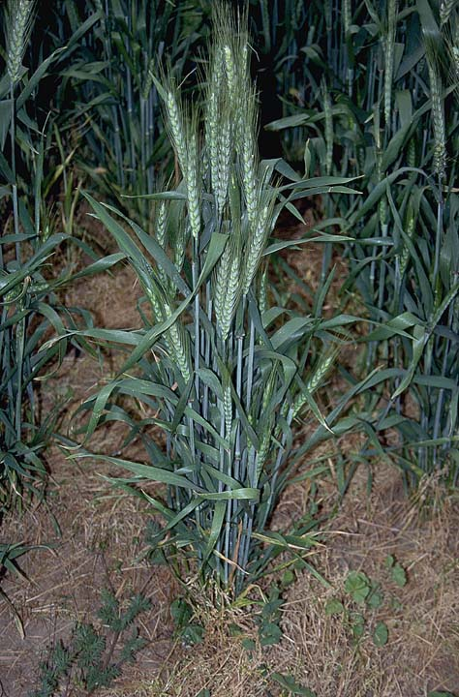
Highly Susceptible: Anza, Express, Summit, Yecora Rojo, Blanca Grande

Susceptible: Clear White, Joaquin, Mika, Paloma, Blanca Royal

Resistant: Blanca Fuerte, Cal Rojo, Expresso, Patwin, Ultra, Lariat, Redwing, Lassik

Table 1. 2009 Kern County Durum Wheat Variety Trial Results.

Cultivar | Yield | Test Wt | Plant | †Lodging
 |  |  | Height | at harvest
 | -- lbs/acre -- | -- lbs/bu -- | -inches -
Volante | 6270 | 64.0 | 31 | 1.0
Westmore | 6270 | 63.4 | 33 | 1.0
Fortissimo | 6160 | 61.4 | 31 | 1.0
Crown | 6010 | 60.6 | 35 | 1.0
Desert King | 6010 | 62.4 | 35 | 1.0
Saragolla | 5790 | 63.2 | 31 | 1.0
Maestrale | 5390 | 63.5 | 37 | 1.5
Platinum | 5260 | 62.3 | 32 | 1.0
Duraking | 5120 | 62.5 | 34 | 1.0
Kronos | 5100 | 61.3 | 32 | 1.0
Q-Max | 4260 | 59.7 | 34 | 1.0
††UCD 08201/21 | 6600 | 64.0 | 35 | 1.0
Mean | 5430 | 62.0 | 34 | 1.6
CV % | 10.3 | 0.7 | 4.9 | 20.5
LSD_{0.05} | 780 | 1.0 | 3.0 | 0.5

†Ratings scale for diseases (area of flag leaf affected) and lodging: 1 = 0-3%, 2 = 4-14%,
3 = 15-29%, 4 = 30-49%, 5 = 50-69%, 6 = 70-84%, 7 = 85-95%, 8 = 96-100%.
††Top yielding experimental variety included for comparison.
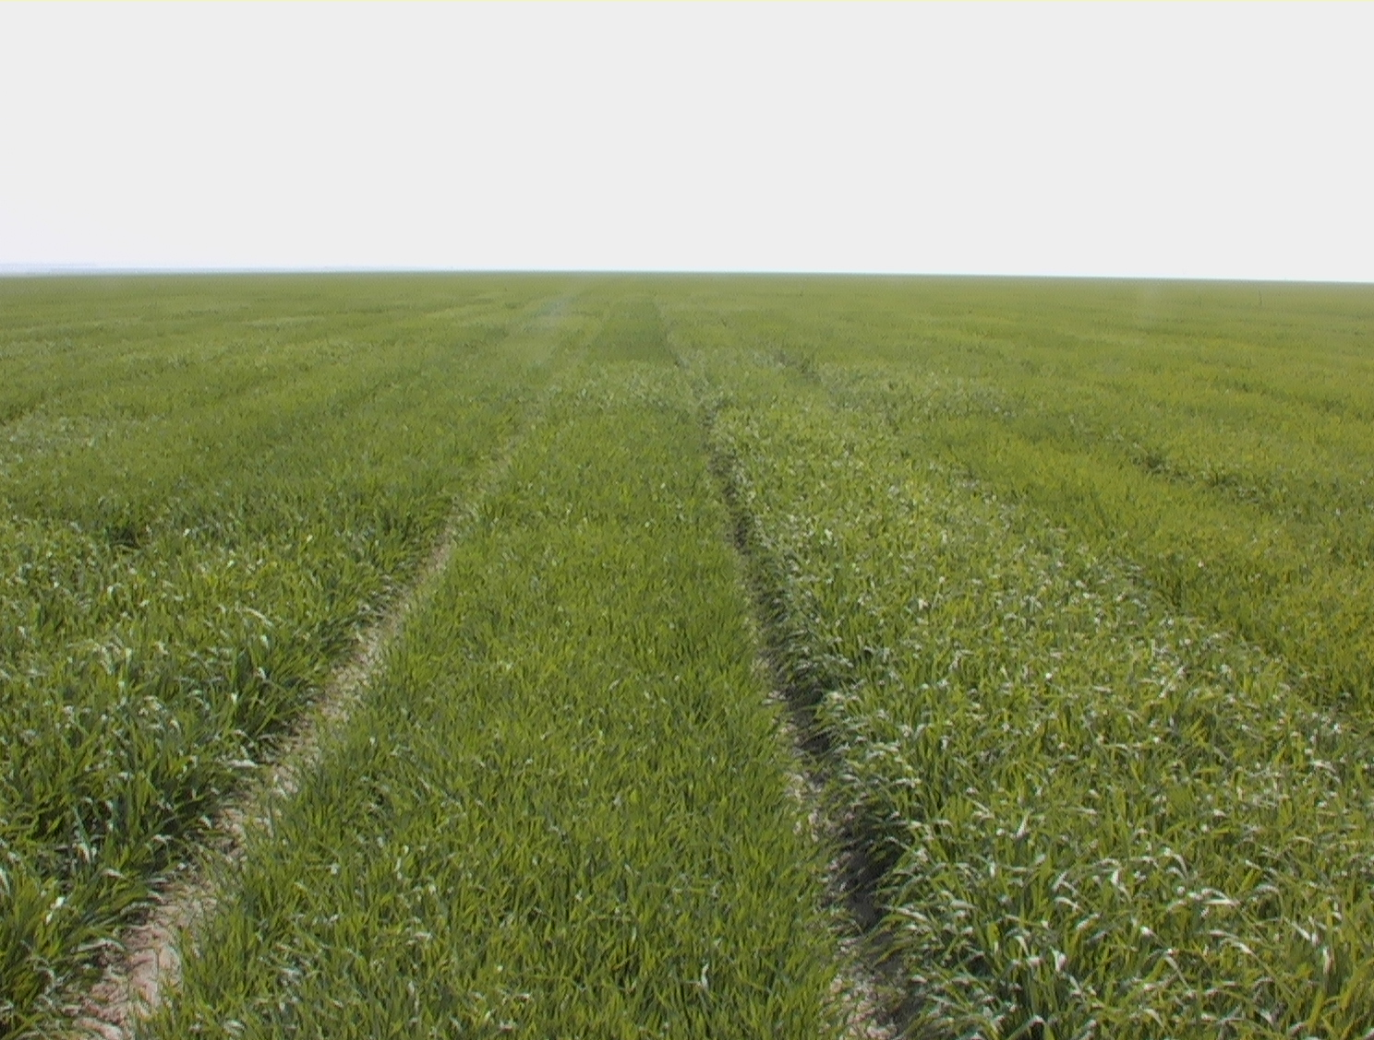

Planted: December 10, 2008
Prior Crop: cotton
Fertilizer: about 200# N total
Seeding Rate: 1,200,000 seeds/acre
Water Applied about 2.5 acre feet
Harvested: June 10, 2009

Table 2. 2009 Kern County Common Wheat and Triticale Variety Trial Results.

Variety | Yield | Test Wt | Plant | †Lodging | Protein | †Stripe
 |  |  | Height | at harvest |  | Rust
 | -- lbs/acre -- | -- lbs/bu -- | -inches - |  | --- % ---
Wheat
Lassik | 6180 | 62.8 | 34 | 1.0 | 13.55 | 1.0
Blanca Grande | 5970 | 63.6 | 35 | 1.0 | 14.24 | 2.4
Joaquin | 5590 | 62.0 | 33 | 1.0 | 15.50 | 2.0
Paloma | 5580 | 61.9 | 34 | 1.0 | 14.61 | 1.6
Blanca Royale | 5550 | 61.7 | 31 | 1.0 | 13.95 | 1.8
Christallo | 5490 | 62.3 | 34 | 1.0 | 14.34 | 1.0
Blanca Fuerte | 5440 | 62.3 | 30 | 1.0 | 13.45 | 1.1
Redwing | 5380 | 60.2 | 29 | 1.0 | 15.17 | 1.1
Patwin | 5270 | 60.5 | 33 | 1.0 | 14.38 | 1.1
Lariat | 5240 | 62.0 | 33 | 1.0 | 13.73 | 1.1
Expresso | 5200 | 62.3 | 38 | 1.0 | 15.20 | 1.0
Clear White | 5020 | 61.3 | 36 | 1.0 | 14.28 | 1.6
Cal Rojo | 4560 | 59.6 | 28 | 1.0 | 14.74 | 1.0
Mika | 4530 | 60.0 | 44 | 1.0 | 16.02 | 1.3
Yecora Rojo | 4260 | 62.0 | 26 | 1.0 | 13.94 | 5.6
Anza | 4160 | 59.9 | 35 | 1.0 | 12.54 | 4.3
Express | 3790 | 61.1 | 35 | 1.0 | 15.18 | 2.4
††UCD 08013/24 | 6490 | 62.5 | 35 | 1.0 | 13.67 | 1.1
Triticale
Pacheco | 6290 | 59.4 | 40 | 1.0 |  | 1.5
Trical Brand 105 | 6290 | 56.7 | 40 | 1.0 |  | 1.1
Trical Brand 110 | 5490 | 56.3 | 33 | 1.0 |  | 2.7
Trical Brand 118 | 5360 | 56.5 | 36 | 1.0 |  | 1.4
Trical Brand 98 | 3270 | 50.0 | 34 | 1.0 |  | 4.0
Mean | 5090 | 60.8 | 35 | 1.3 |  | 1.8
CV % | 12.7 | 1.0 | 4.5 | 22.8 |  | 45.9
LSD_{0.05} | 900 | 1.3 | 3 | 0.4 |  | 0.5
†Ratings scale for diseases (area of flag leaf affected) and lodging: 1 = 0-3%, 2 = 4-14%,
3 = 15-29%, 4 = 30-49%, 5 = 50-69%, 6 = 70-84%, 7 = 85-95%, 8 = 96-100%.
††Top yielding experimental variety included for comparison.


Brian Marsh, Farm Advisor/Center Director

Cotton, Small Grains, Corn & Silage

The University of California prohibits discrimination or harassment of any person on the basis of race, color, national origin, religion, sex, gender identity, pregnancy (including childbirth, and medical conditions related to pregnancy or childbirth), physical or mental disability, medical condition (cancer-related or genetic characteristics), ancestry, marital status, age, sexual orientation, citizenship, or service in the uniformed services (as defined by the Uniformed Services Employment and Reemployment Rights Act of 1994: service in the uniformed services includes membership, application for membership, performance of service, application for service, or obligation for service in the uniformed services) in any of its programs or activities. University policy also prohibits reprisal or retaliation against any person in any of its programs or activities for making a complaint of discrimination or sexual harassment or for using or participating in the investigation or resolution process of any such complaint. University policy is intended to be consistent with the provisions of applicable State and Federal laws. Inquiries regarding the University’s nondiscrimination policies may be directed to the Affirmative Action/Equal Opportunity Director, University of California, Agriculture and Natural Resources, 1111 Franklin Street, 6th Floor, Oakland, CA 94607, (510) 987-0096.

