

University of California Cooperative Extension
KERN VEGETABLE CROPS

Kern County • 1031 S. Mt. Vernon Avenue • Bakersfield, CA 93307 • 661-868-6222

October 2007

We are cleaning out our warehouse at the UC Cooperative Extension in preparation for some remodeling. I came across some old Potato Growers Association of California yearbooks. Apparently the Potato Growers Association of California was a very large organization and was located here in Bakersfield at 931 Union Ave. I’ll share the yearbooks at the next Potato Field Day and Dinner in June 2008. I found the following article about the history of Kern County potatoes in the 1969 yearbook that was particularly interesting. I thought you might enjoy reading about some of the farming history of Kern County.

California Potatoes
. . . Historical Background
by
Francis P. Pusateri, Executive Manager Potato Growers Association of California

KERN DISTRICT . . . (Kern and Tulare Counties)

The development of Kern District’s multi-million dollar potato industry began with 300 acres in 1920, rose to a peak of 65,000 acres in 1946 and settled down to about 40,000 to 45,000 acres since that time. Miles of fertile, level land, many days of life-giving sunshine, efficient management, evolution of cultural and irrigation methods – plus the discovery of the White Rose (“Long White”) potato, which grows vigorously and produces well under Kern’s climatic conditions – are among the leading factors which contributed to the phenomenal growth of this industry.
Imagination and energetic work on the part of Kern County potato pioneers are responsible for this history-making enterprise. In 1912, George H. Peters planted one of the first commercial fields in the Weedpatch area, southeast of Bakersfield. In the Shafter section, Robert Neuman planted and harvested some of the first acreage. During the early days, no fertilizer was used and on the best land 150 sacks to the acre was considered a bumper crop. Today, through the use of proper applications of fertilizer and modern cultural methods, it is not uncommon to produce, grade and pack 400 sacks (100 pounds each) of U.S. No. One grade Long Whites per acre.
Up to 1936 the acreage of potatoes in Kern District grew gradually but slowly. During this time growers were gathering know-how, which later was to produce dividends in high yields and high quality. In 1937 the acreage went over 22,000 and from this point on the increase was rapid and constant.
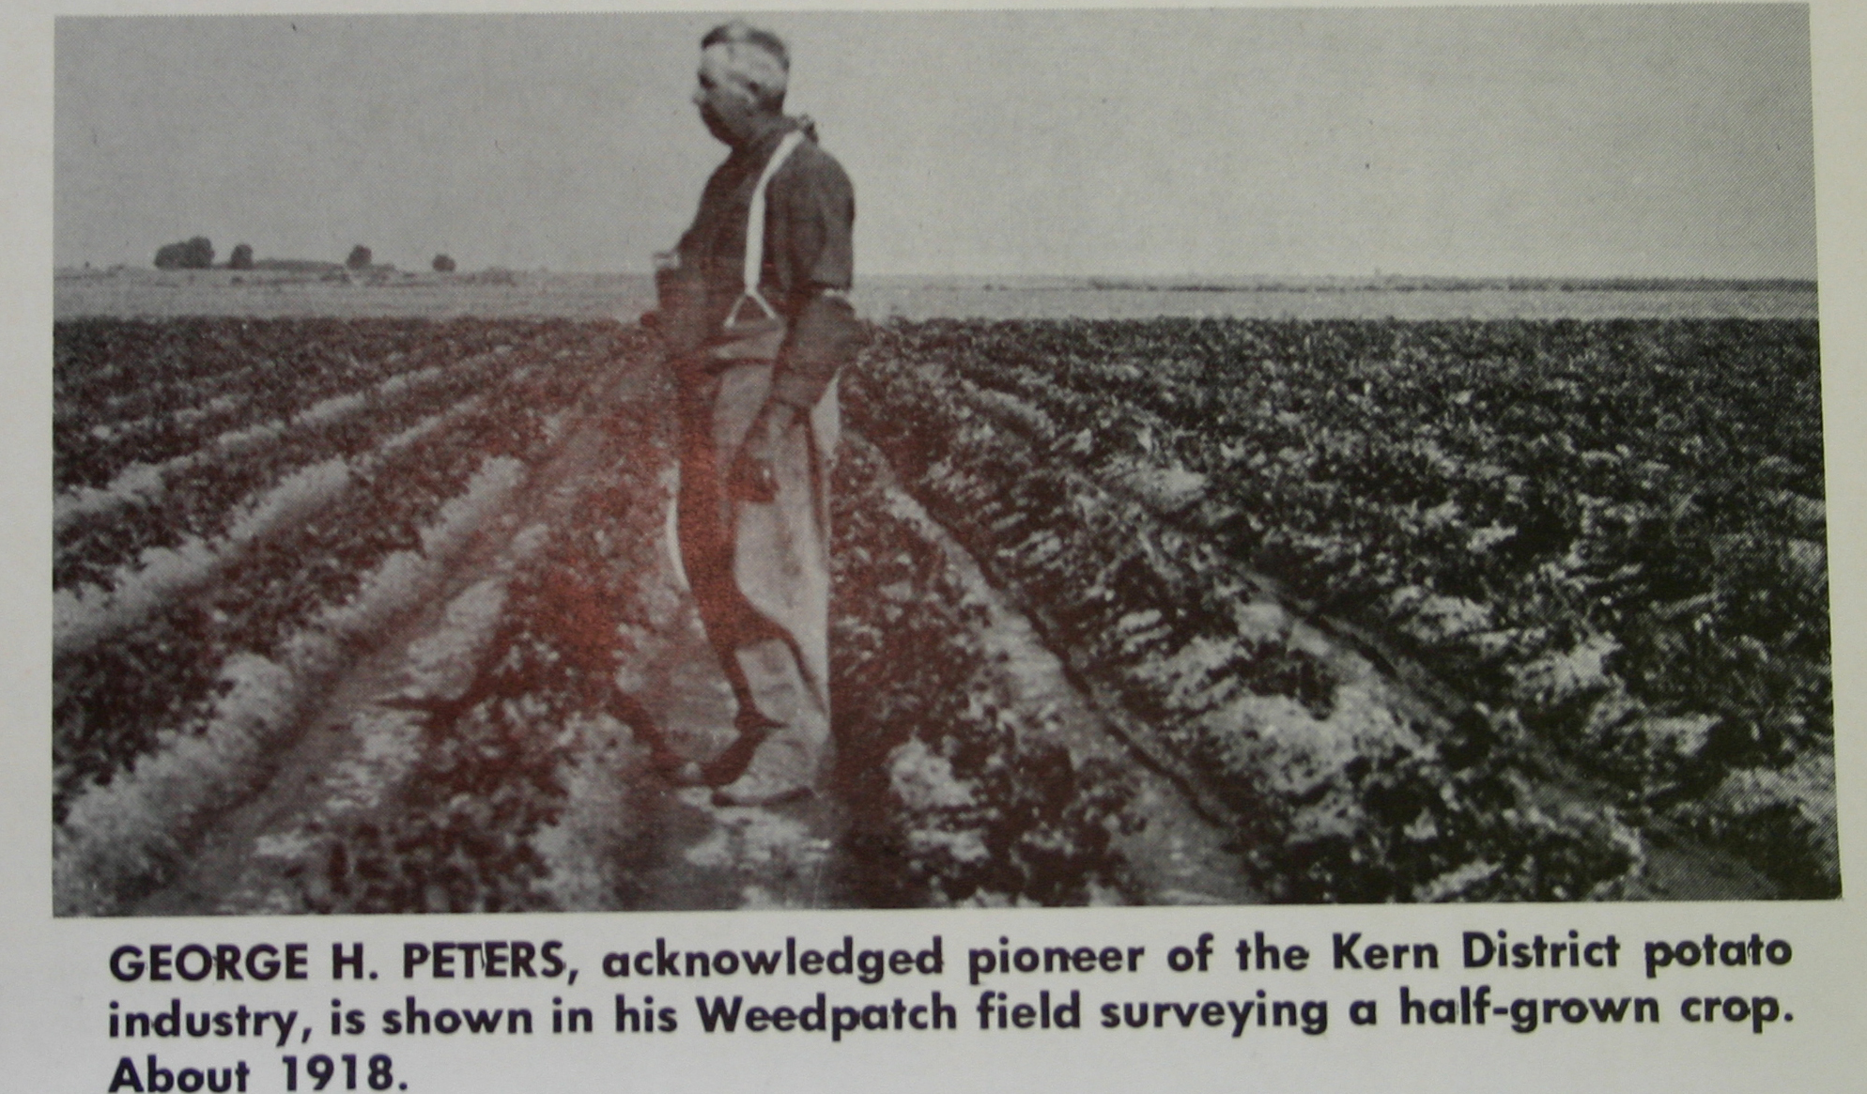
Potatoes are planted at elevations ranging from 100 to 4500 feet above sea level in Kern District, but the bulk are grown on the floor of the southern San Joaquin Valley, where the rainfall is less than 6 inches a year. As with all desert areas, the ability to obtain water was one of the principal problems to overcome before extensive agriculture could be practiced. Kern County has a large, but diminishing, reservoir of underground water – but it was too deep to be brought to the surface economically by early pumps. The deepwell turbine pumps changed this picture and allowed many acres to be brought under production

The Kern potato empire embraces Wheeler Ridge, Rosedale, Shafter, Saco, Wasco, Cawelo, Pond, Slater, Famoso, Lerdo, Arvin, Lamont, Edison, Delano, McFarland and Earlimart. Today Kern is the second leading potato producing county in the United States – second only to Aroostook County, Maine. California is the third ranking state in potato production – behind Idaho and Maine – and Kern District grows over half the state’s crop, as well as supplying more than half of all potatoes consumed in the entire nation from April through July.
The White Rose variety – better known as the “Long White” – is not a new variety and had been tried in other areas of the U.S., but had practically disappeared until its revival in Kern District, when it was found to be particularly well adapted to this area.
The average yield per acre in 1920 was 100 hundredweight, while the average in recent years has been close to 350. This increase in yield is the result of experiments conducted by growers, the U.S. Department of Agriculture and the Agricultural Extension Service of the University of California. Improved strains of vigorous certified seed potatoes have also helped heighten yield and quality.
Seed potatoes come from Washington, Oregon, Utah, Minnesota, North and South Dakota, and from California. In addition to the famous Long White, varieties planted in Kern District today include the Round Red, Kennebec (for chipping), Norgold Russet and Russet Burbank.
In pioneer days, potatoes were packed in 100-pound burlap bags in the field, unwashed and casually graded. Often the sacks were secondhand. Starting about 1930, growers began building packing plants and hauling their potatoes from the fields for washing and grading. Improved methods of harvesting and packing have naturally evolved through the years until today, Kern District boasts perhaps the largest, best-equipped, most efficient potato plants in the world.
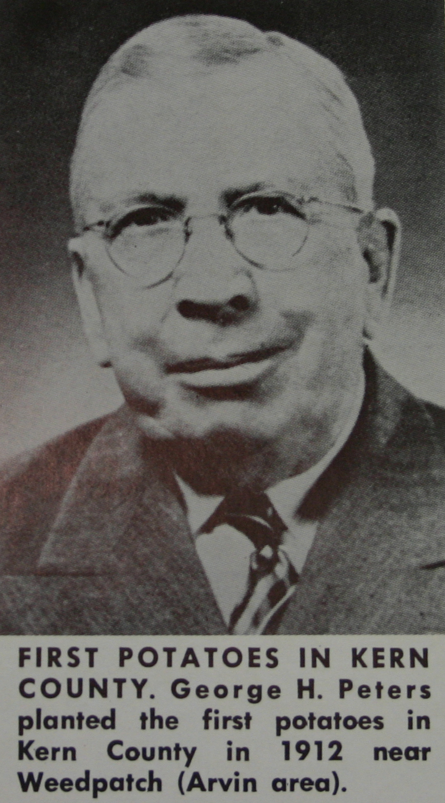
Early shipments of Kern potatoes came mostly from Shafter and Wasco with Shafter as the headquarters, where buyers and brokers met regularly to transact business. New acreage began opening in Edison and Arvin and then spread to Delano, McFarland and Earlimart. The industry became so widespread that buyers and brokers made Bakersfield their headquarters, where hotels were adequate. For many years the El Tejon Hotel and later the famed Bakersfield Inn were potato “GHQ’s” for Kern District.
To knit their industry together formally through a trade and service organization of voluntary membership, forty growers met on February 11, 1944 and incorporated the “Kern County Potato Growers Association,” which has since become the “Potato Growers Association of California.” Many of those forty men are still growing potatoes in Kern District and are still active in the Association.
From 1944 to 1968 the Association has consistently dedicated itself to the advancement of the potato industry and, with justifiable pride, the Kern potato industry can say that it has advanced remarkably since that first field planted in 1912.

* * * * * * * * * * *

2007 Kern County Potato Variety Trial

We harvested the 2007 Kern County Potato Variety Trial in June and had the Field Day and dinner on June 21. The variety trial is composed of the Southwest Regional Trial which is varieties produced by Texas A&M and material from Colorado State University. Varieties produced by these two universities seem to be well adapted to Kern County’s climate so it is import to be part of the Southwest regional Trial. The second component is the Kern County Replicated Trial. It is made up of material that Kern County potato growers find interesting and want a better look at. Often material from the Kern County Observational Trial makes it into the Kern Replicated Trial. The Kern County Observational trial is material that I pick up from various breeders throughout North America. The goal is to try as many varieties as we can and see what may or may not work in Kern County.
In the Southwest Regional Trial, AOTX96265-2RU, ATX97147-4RU, and ATX97232-1RU all performed better than the standard Russet, Russet Norkotah-3. There were several outstanding russets in the Kern Replicated Trial. TXA549-4RU, AOTX95265-2ARU, AOTX95265-4RU, CO97087-2RU, CO95172-3RU, and Rio Grande Russet were outstanding performers.
For the red skin varieties in the Southwest Trial, CO99076-6R, NDTX4784-7R, and COtx00104-7R looked very good and yielded well. In the Kern County Replicated Trial, NY97, NDTX4304-1R, and NDTX4271-5R looked very promising.
In the specialty types there were a lot of interesting varieties with many yellows, purples, reds, and some combinations. Some standouts were NY 125, ATTX961014-1R/Y, ATTX98500-2P/Y, CO97274-2W/Y, and Emergo. There were also a lot of promising varieties in the Observational Trial, including russets, reds, and specialty. It will be difficult to pick just a few to put in the replicated trial next year.

 | Planted 2/21/07 Tubers harvested 6/11/07.
 |  | Southwest Regional Trial 2007
 |  |  | CWT/A
 |  |  | 0-4 oz | 4-6 oz | 6-10oz | 11 oz & > | Culls | Total | Marketable | Vigor
1 | All Blue |  | 174.2 | 109.3 | 57.0 | 0.0 | 1.7 | 342.2 | 166.3 | 3.3
2 | Atlantic |  | 28.4 | 88.4 | 281.7 | 1.9 | 6.4 | 406.8 | 372.0 | 4.0
3 | Chipeta |  | 37.2 | 97.2 | 303.4 | 3.4 | 3.0 | 444.1 | 404.0 | 4.0
4 | Norland (Dark Red) |  | 28.8 | 98.5 | 184.3 | 11.4 | 5.6 | 328.6 | 294.2 | 2.0
5 | Red LaSoda |  | 34.1 | 106.0 | 273.0 | 9.0 | 4.6 | 426.7 | 388.0 | 3.0
6 | Russet Norkotah |  | 58.2 | 44.2 | 177.1 | 0.0 | 2.0 | 281.6 | 221.3 | 2.3
7 | Russet Norkotah-S3 |  | 65.1 | 58.0 | 187.3 | 19.9 | 7.9 | 338.2 | 265.2 | 3.0
8 | Russet Norkotah 278 |  | 58.0 | 43.0 | 127.4 | 0.0 | 5.0 | 233.4 | 170.4 | 1.5
9 | Yukon Gold |  | 19.6 | 44.8 | 265.5 | 35.3 | 14.3 | 379.6 | 345.7 | 3.3
10 | AC99213-8W |  | 71.7 | 130.6 | 109.6 | 0.0 | 5.7 | 317.6 | 240.2 | 3.0
11 | AC99329-7PW/Y |  | 48.6 | 82.9 | 221.6 | 11.2 | 8.9 | 373.3 | 315.8 | 4.0
12 | AC99330-1P/Y |  | 111.5 | 88.8 | 37.2 | 0.0 | 5.2 | 242.7 | 126.0 | 3.3
13 | CO99045-1W/Y |  | 116.2 | 98.4 | 188.8 | 10.7 | 6.1 | 420.2 | 297.9 | 3.8
14 | CO99076-6R |  | 40.0 | 137.8 | 160.9 | 0.0 | 0.0 | 338.7 | 298.7 | 3.3
15 | CO99256-2R |  | 107.4 | 109.4 | 119.4 | 0.0 | 7.1 | 343.4 | 228.9 | 3.0
16 | CO99256-3R |  | 138.8 | 97.4 | 30.6 | 0.0 | 9.4 | 276.3 | 128.0 | 3.0
17 | CO99338-3RU/Y |  | 98.0 | 92.7 | 109.0 | 0.0 | 2.2 | 302.0 | 201.7 | 2.3
18 | CO98067-7RU |  | 98.4 | 59.4 | 157.8 | 0.0 | 5.9 | 321.6 | 217.3 | 3.0
19 | CO98368-2RU |  | 100.7 | 52.1 | 92.9 | 0.0 | 5.2 | 250.8 | 145.0 | 3.0
20 | AOTX96265-2RU |  | 33.9 | 80.9 | 214.3 | 0.0 | 3.9 | 332.9 | 295.2 | 3.0
21 | AOTX98137-1RU |  | 66.6 | 36.8 | 138.8 | 0.0 | 1.9 | 244.1 | 175.6 | 2.5
22 | ATTX98453-6R |  | 69.2 | 120.9 | 39.2 | 0.0 | 3.9 | 233.2 | 160.1 | 1.5
23 | ATX97147-4RU |  | 94.7 | 61.1 | 233.6 | 9.0 | 10.7 | 409.1 | 303.6 | 2.5
24 | ATX97232-1RU |  | 68.0 | 71.8 | 212.8 | 0.0 | 13.0 | 365.5 | 284.5 | 3.0
25 | NDTX4784-7R |  | 56.2 | 102.8 | 169.5 | 3.5 | 3.1 | 335.0 | 275.8 | 2.8
26 | ATTX98500-3P/Y |  | 98.6 | 48.0 | 109.0 | 0.0 | 10.5 | 266.2 | 157.0 | 3.8
27 | ATX9132-2RU |  | 93.1 | 5.1 | 3.6 | 0.0 | 0.0 | 101.8 | 8.7 | 3.8
28 | COTX94218-1R |  | 118.0 | 105.3 | 42.8 | 0.0 | 3.7 | 269.7 | 148.0 | 2.8
29 | COTX00104-7R |  | 38.4 | 104.9 | 207.9 | 0.0 | 18.3 | 369.4 | 312.7 | 2.5
30 | AOTX95295-3RU |  | 64.5 | 39.5 | 167.2 | 0.0 | 3.7 | 274.9 | 206.7 | 2.8

 |  | Kern County Replicated Trial
 |  | CWT/A
 |  | 0-4 oz | 4-6 oz | 6-10oz | 11 oz & > | Culls | Total | Marketable | Vigor
31 | NY 97 | 48.8 | 58.2 | 301.9 | 0.0 | 6.5 | 415.4 | 360.1 | 2.8
32 | NY 125 | 48.8 | 89.8 | 221.8 | 11.0 | 2.7 | 374.2 | 322.7 | 2.8
33 | ATTX95490-2W | 29.8 | 73.9 | 498.9 | 91.0 | 40.0 | 733.6 | 663.8 | 3.8
34 | NDTX4304-1R | 27.0 | 102.5 | 269.3 | 30.1 | 28.4 | 457.3 | 401.9 | 3.0
35 | NDTX4271-5R | 35.7 | 124.1 | 318.5 | 5.1 | 8.3 | 491.8 | 447.8 | 2.5
36 | TXA549-4RU | 45.1 | 68.2 | 283.8 | 55.8 | 40.1 | 493.1 | 407.9 | 3.8
37 | AOTX95265-2ARU | 40.0 | 56.5 | 228.2 | 24.2 | 12.6 | 361.4 | 308.8 | 2.5
38 | AOTX95265-3RU | 57.8 | 47.2 | 174.8 | 20.2 | 13.4 | 313.3 | 242.2 | 2.0
39 | AOTX95265-4RU | 40.4 | 50.5 | 271.0 | 21.4 | 3.6 | 386.9 | 342.9 | 2.5
40 | ATTX961014-1R/Y | 59.8 | 82.9 | 246.9 | 11.9 | 20.4 | 422.0 | 341.7 | 3.3
41 | ATTX98500-2P/Y | 78.4 | 210.0 | 173.2 | 10.8 | 7.1 | 479.5 | 394.0 | 3.8
42 | ATX91137-1RU | 48.0 | 36.5 | 210.1 | 25.5 | 19.0 | 339.2 | 272.2 | 2.0
43 | Stampede Russet | 39.6 | 43.2 | 275.3 | 73.3 | 6.8 | 438.3 | 391.8 | 3.3
44 | CO97274-2W/Y | 27.6 | 45.4 | 224.5 | 56.9 | 94.8 | 449.2 | 326.8 | 3.0
45 | CO97087-2RU | 32.9 | 79.3 | 225.3 | 12.5 | 14.0 | 364.0 | 317.1 | 2.8
46 | CO97138-3RU | 38.2 | 25.0 | 182.9 | 12.0 | 30.8 | 288.9 | 219.9 | 3.0
47 | CO95172-3RU | 93.9 | 82.2 | 225.3 | 0.0 | 10.3 | 411.7 | 307.5 | 3.0
48 | Rio Grande Russet | 54.9 | 106.9 | 217.7 | 14.3 | 5.4 | 399.2 | 338.8 | 3.3
49 | RZD 94-2262=Emergo | 44.5 | 76.6 | 293.6 | 38.0 | 20.5 | 473.2 | 408.2 | 2.5

 |  | Kern County Observational Trial
 |  | CWT/A
 |  | 0-4 oz | 4-6 oz |  | 6-10oz | 11 oz & > | Culls | Total | Marketable | Vigor
51 | NY 126 | 28.6 | 111.1 |  | 137.2 | 0.0 | 21.2 | 298.1 | 248.3 | 3
52 | NY 141 | 18.0 | 30.2 |  | 232.0 | 0.0 | 58.4 | 338.5 | 262.2 | 3
53 | MSJ 126-9Y | 36.8 | 107.8 |  | 47.4 | 0.0 | 20.4 | 212.4 | 155.2 | 3
54 | MSL 007-B | 61.3 | 104.5 |  | 181.3 | 0.0 | 3.3 | 350.4 | 285.9 | 3
55 | MSJ 461-1 | 46.6 | 140.5 |  | 283.4 | 0.0 | 9.4 | 479.8 | 423.9 | 3
56 | MSK 409-1 | 47.4 | 80.9 |  | 150.3 | 22.1 | 21.6 | 322.2 | 253.2 | 3
57 | MSJ316-A | 53.1 | 67.8 |  | 414.9 | 24.5 | 8.2 | 568.5 | 507.2 | 4
58 | Jacqueline Lee | 91.5 | 31.9 |  | 285.9 | 0.0 | 3.7 | 412.9 | 317.7 | 3
59 | MSA 8254-2BRUS | 44.9 | 66.2 |  | 276.5 | 35.1 | 12.3 | 434.9 | 377.7 | 3
60 | MSJ 147-1 | 133.9 | 117.6 |  | 62.9 | 0.0 | 5.3 | 319.8 | 180.5 | 3
61 | Michigan Purple | 31.9 | 75.1 |  | 293.2 | 28.6 | 11.4 | 440.2 | 396.9 | 3
62 | MSJ 036-A | 52.3 | 94.7 |  | 432.5 | 0.0 | 0.0 | 579.5 | 527.2 | 4
63 | MSI 005-20Y | 45.7 | 91.5 |  | 238.5 | 0.0 | 49.4 | 425.1 | 330.0 | 3
64 | A93157-6LS | 35.9 | 31.0 |  | 365.9 | 46.6 | 0.0 | 479.4 | 443.5 | 3
65 | A95109-1 | 40.8 | 26.1 |  | 471.3 | 71.5 | 7.4 | 617.1 | 568.9 | 4
66 | AO96160-3 | 126.6 | 79.2 |  | 283.4 | 0.0 | 0.0 | 489.2 | 362.6 | 4
67 | NDTX4847-7R | 46.6 | 60.8 |  | 127.4 | 0.0 | 40.8 | 275.7 | 188.3 | 2
68 | BTX1749-1W/Y | 32.7 | 54.7 |  | 34.3 | 0.0 | 20.0 | 141.7 | 89.0 | 1
69 | NDTX4756-1R/Y | 89.0 | 102.1 |  | 18.0 | 0.0 | 0.0 | 209.1 | 120.1 | 2
70 | TX1674-1W/Y | 78.4 | 91.5 |  | 96.4 | 0.0 | 13.9 | 280.1 | 187.9 | 3
71 | UNTX383-3WRE/Y | 43.3 | 23.3 |  | 44.9 | 0.0 | 8.2 | 119.7 | 68.2 | 1
72 | AC97044-4RU | 57.2 | 49.8 |  | 79.2 | 0.0 | 18.0 | 204.2 | 129.0 | 3
73 | AC99375-1RU | 39.2 | 82.5 |  | 263.0 | 43.7 | 28.2 | 456.6 | 389.2 | 4
74 | AC99178-2RU | 63.7 | 49.0 |  | 260.5 | 0.0 | 7.4 | 380.6 | 309.5 | 4
75 | CO99028-2RU | 125.8 | 29.4 |  | 48.2 | 0.0 | 4.9 | 208.3 | 77.6 | 3
76 | CO99053-3RU | 120.9 | 16.3 |  | 205.0 | 0.0 | 13.9 | 356.1 | 221.3 | 3
77 | CO99053-4RU | 107.0 | 38.8 |  | 167.4 | 13.9 | 5.7 | 332.8 | 220.1 | 3
78 | CO99100-1RU | 30.2 | 25.7 |  | 334.5 | 0.0 | 18.0 | 408.4 | 360.2 | 3
79 | CO99199-1RU | 51.5 | 14.7 |  | 286.7 | 0.0 | 9.8 | 362.6 | 301.4 | 3
80 | VC1115-1RU | 87.4 | 112.7 |  | 338.1 | 0.0 | 5.7 | 544.0 | 450.8 | 3
81 | ATDC9801-3P | 57.2 | 183.0 |  | 225.8 | 0.0 | 18.8 | 484.7 | 408.8 | 3
82 | CO98012-5R | 92.3 | 122.5 |  | 191.5 | 0.0 | 2.5 | 408.8 | 314.0 | 3
83 | CO98277-4W | 63.7 | 113.5 |  | 223.0 | 0.0 | 7.8 | 408.0 | 336.5 | 3
84 | CO97215-2P/P | 79.2 | 51.5 |  | 191.9 | 0.0 | 2.5 | 325.1 | 243.4 | 3
85 | CO97222-1R/R | 1 52.7 | 40.8 |  | 149.5 | 0.0 | 2.5 | 345.5 | 190.3 | 3
86 | ATC98495-1W/Y | 89.0 | 187.0 |  | 401.4 | 0.0 | 0.8 | 678.3 | 588.5 | 4
Kern County Observational Trial
(Continued)
 |  | CWT/A
 |  | 0-4 oz | 4-6 oz | 6-10oz |  | 11 oz & > | Culls | Total | Marketable | Vigor
87 | CO97227-2P/PW | 258.9 | 57.6 | 0.0 |  | 0.0 | 0.0 | 316.5 | 57.6 | 3
88 | Colorado Rose | 47.4 | 126.6 | 401.0 |  | 0.0 | 5.3 | 580.3 | 527.6 | 3
89 | NDC5281-2R | 127.4 | 62.1 | 276.9 |  | 0.0 | 9.0 | 475.3 | 339.0 | 3
90 | CO94035-15RU | 50.6 | 87.4 | 303.4 |  | 31.9 | 12.7 | 486.0 | 422.7 | 3
91 | CO95086-8RU | 44.1 | 15.5 | 113.5 |  | 0.0 | 25.7 | 198.9 | 129.0 | 3
92 | AC97521-1R/Y | 86.6 | 9.0 | 137.2 |  | 0.0 | 25.3 | 258.1 | 146.2 | 3
94 | MN 02 589 | 90.7 | 161.7 | 60.4 |  | 0.0 | 14.7 | 327.5 | 222.2 | 4
95 | MN 02 598 | 53.1 | 98.0 | 243.4 |  | 0.0 | 47.8 | 442.3 | 341.4 | 4
96 | MN 00177-5 | 44.9 | 51.9 | 199.7 |  | 0.0 | 19.6 | 316.1 | 251.6 | 3
97 | MN 99460-14 | 30.2 | 34.3 | 253.6 |  | 7.4 | 15.5 | 341.0 | 295.3 | 3
98 | COMN 03019-4 | 34.3 | 88.2 | 243.4 |  | 33.1 | 17.6 | 416.5 | 364.7 | 3
99 | NDMN 03314-1 | 96.4 | 224.6 | 50.6 |  | 6.9 | 22.5 | 401.0 | 282.2 | 3
100 | NDMN 03382-2 | 117.6 | 213.2 | 47.4 |  | 0.0 | 12.7 | 390.8 | 260.5 | 3
101 | Monet = Cyrano | 112.7 | 83.3 | 229.9 |  | 0.0 | 2.5 | 428.4 | 313.2 | 3
102 | Felsina | 35.1 | 78.8 | 382.6 |  | 42.5 | 48.2 | 587.2 | 503.9 | 3
103 | Snowbird | 46.6 | 66.2 | 330.8 |  | 0.0 | 6.5 | 450.0 | 396.9 | 3
104 | Sifira | 61.3 | 74.7 | 337.7 |  | 6.5 | 0.0 | 480.2 | 419.0 | 3
105 | Kenita | 94.7 | 99.6 | 389.2 |  | 77.6 | 11.0 | 672.2 | 566.4 | 3
106 | Annabelle | 116.0 | 62.1 | 168.3 |  | 0.0 | 18.8 | 365.1 | 230.3 | 3
107 | Courage | 61.3 | 65.7 | 210.7 |  | 0.0 | 0.0 | 337.7 | 276.5 | 3
108 | Harmony | 79.2 | 128.2 | 45.7 |  | 0.0 | 20.4 | 273.6 | 174.0 | 2
109 | Valor | 46.6 | 98.0 | 210.4 |  | 0.0 | 6.1 | 361.1 | 308.4 | 3
110 | US 307-93 Gala | 42.5 | 29.4 | 49.8 |  | 0.0 | 2.9 | 124.6 | 79.2 | 3
111 | US 149-69 | 43.3 | 55.5 | 54.7 |  | 0.0 | 7.8 | 161.3 | 110.3 | 3
112 | US 476-94 | 20.4 | 30.2 | 65.3 |  | 0.0 | 0.0 | 116.0 | 95.6 | 3
113 | US 689-89 | 22.9 | 0.0 | 62.1 |  | 0.0 | 0.0 | 84.9 | 62.1 | 3

Joe Nunez, Farm Advisor
The University of California prohibits discrimination against or harassment of any person employed by or seeking employment with the University on the basis of race, color, national origin, religion, sex, physical or mental disability, medical condition (cancer-related or genetic characteristics), ancestry, marital status, age, sexual orientation, citizenship, or status as a covered veteran (special disabled veteran, Vietnam-era veteran or any other veteran who served on active duty during a war or in a campaign or expedition for which a campaign badge has been authorized). Inquiries regarding the University’s nondiscrimination policies may be directed to the Affirmative Action/Staff Personnel Services Director, University of California, Agriculture and Natural Resources, 1111 Franklin Street, 6th Floor, Oakland, CA 94607-5200, (510) 987-0096. University Policy is intended to be consistent with the provision of applicable State and Federal laws.
Vegetable Crops/Plant Pathology

